
Pupil premium strategy statement

Oakwood Junior School

2024

-

2025

‘Every child is a learner and can achieve’.

Safety

Positivity

Aspiration

Resilience

Respect

Kindness

This statement details our school’s use of pupil premium (and recovery premium for the 2021 to 2024 academic years) funding to help improve the attainment of our disadvantaged pupils. It outlines our pupil premium strategy, how we intend to spend the funding and the effect that previous spending of pupil premium had within our school.

School overview
Detail | Data
Number of pupils in school | 345
Proportion (%) of pupil premium eligible pupils | 48% increased to 50.9% March 2025
Academic year/years that our current pupil premium strategy plan covers | 2024-2025 - £243,340  2023 – 2024 - £240,233  2022 – 2023 - £210,370
Date this statement was published | 13th December 2024
Date on which it will be reviewed | March 2025
Statement authorised by Pupil Premium Lead | Ms Atwal
Governor / Trustee lead | Mr Blackwell

Funding overview
Part A: Pupil premium strategy plan

Statement of intent
The Pupil Premium is allocated to schools and academies with pupils who are known to have been eligible for Free School Meals (FSM) at any time in the last six years; those who are Looked After Children (LAC); children who have been Previously Looked After (PLAC) and those who are Service Children.
Our targeted and strategic use of Pupil Premium will support the school in achieving our aim to help every child achieve their full potential and be fully armed to succeed in life regardless of their ability or background.
With proof of having the highest impact on Disadvantaged children’s outcomes, we consider highquality teaching to be at the heart of our approach which allows us to also benefit those children who are non-disadvantaged. Our strategy, which is integral to wider school-plans for education recovery, also involves targeted tuition for small focus groups and 1:1 support in other areas of need allowing us to target both common challenges and individual needs.
Through careful consideration of our school’s context and from carrying out robust, individualised provision maps for all of our Disadvantaged pupils, we have identified our common barriers to learning: poor attendance and punctuality, less support at home / low aspirations, weak language and communication skills, Social Emotional Mental Health (SEMH) issues with a particular focus on mental health, limited life experiences, complex Special Educational Needs Disability (SEND) child protection issues especially pupils being exposed to domestic violence, poor metacognition skills and deprivation factors. Although our Pupil Premium funding is allocated primarily based on the above barriers identified, it is important to understand that there are many more diverse and complex needs within our school and as a result there is no ‘one fits all’ approach used. Instead, we carefully tailor the interventions, tutoring, support, challenge and council to meet the needs of our individual children.
Overcoming barriers to enable our children to become healthy, safe, able to access the full KS2 curriculum, prepare our year 6’s for a successful transition into year 7 and life-long learners is at the heart of our Pupil Premium funding use as we strongly believe that ‘every child is a learner and can achieve’.
Through ongoing careful analysis of our individual children’s strengths and barriers to learning carried out by all members of staff, we are able to allocate targeted support through interventions of both small group and large groups, year groups, the whole school or in 1:1 capacities before allocating a budget accordingly. We understand that circumstances can change and that relationships in schools are paramount to the children’s learning; because of this we revisit the children’s provision maps and monitor data regularly, ensuring that all teaching staff are involved in this whole-school process.

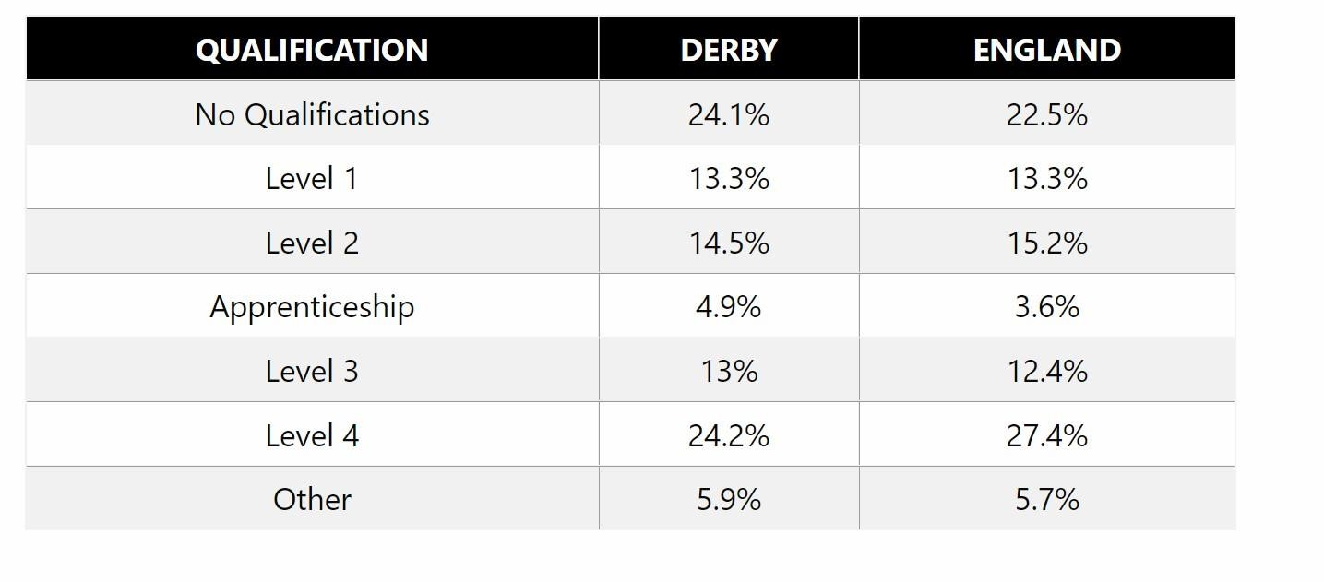

Principles and Priorities

•

To ensure that teaching and learning opportunities meet the needs of all of our students
and that they all have access to consistently high quality
-
first teaching.

•

To narrow the attainment gap between Disadvantaged and Non
-
Disadvantaged pupils.

•

To
support raising pupils’ attendance

•

We recognise that not all children who are considered disadvantaged meet the criteria for
receiving Pupil Premium funding, therefore we endeavour to ensure that all pupils who
school considered to be at any disadvantage can access the funding too.

•

Pupil P
remium funding is also allocated following a needs analysis in the form of
individualised provision maps for all of our Disadvantaged pupils. After identifying the
pupils’ barriers to learning, strategies are put into place by staff in order to enable the
children to overcome these barriers, funded by Pupil Premium funding.

•

We also recognise that not all pupils who are socially disadvantaged are registered or
qualify for free school meals. We reserve the right to allocate the Pupil Premium funding
to suppo
rt any pupil or groups of pupils the school has legitimately identified as being
socially disadvantaged.

Demography and School Context

Our school is a community school based in Alvaston in South Derby. It is a larger than average
three form entry junior school with pupils who are predominantly White British.

The table below taken from 2018 census shows adult education statistics for our

school area

The map below displays the “Lower Super Output Areas” (LSOAs) which surround the school
and they are colour coded according to which national decile they belong to: decile 1 being the
most deprived and decile 10 being the least deprived (IMD rankings). The

dark blue areas
indicate the lowest LSOA.

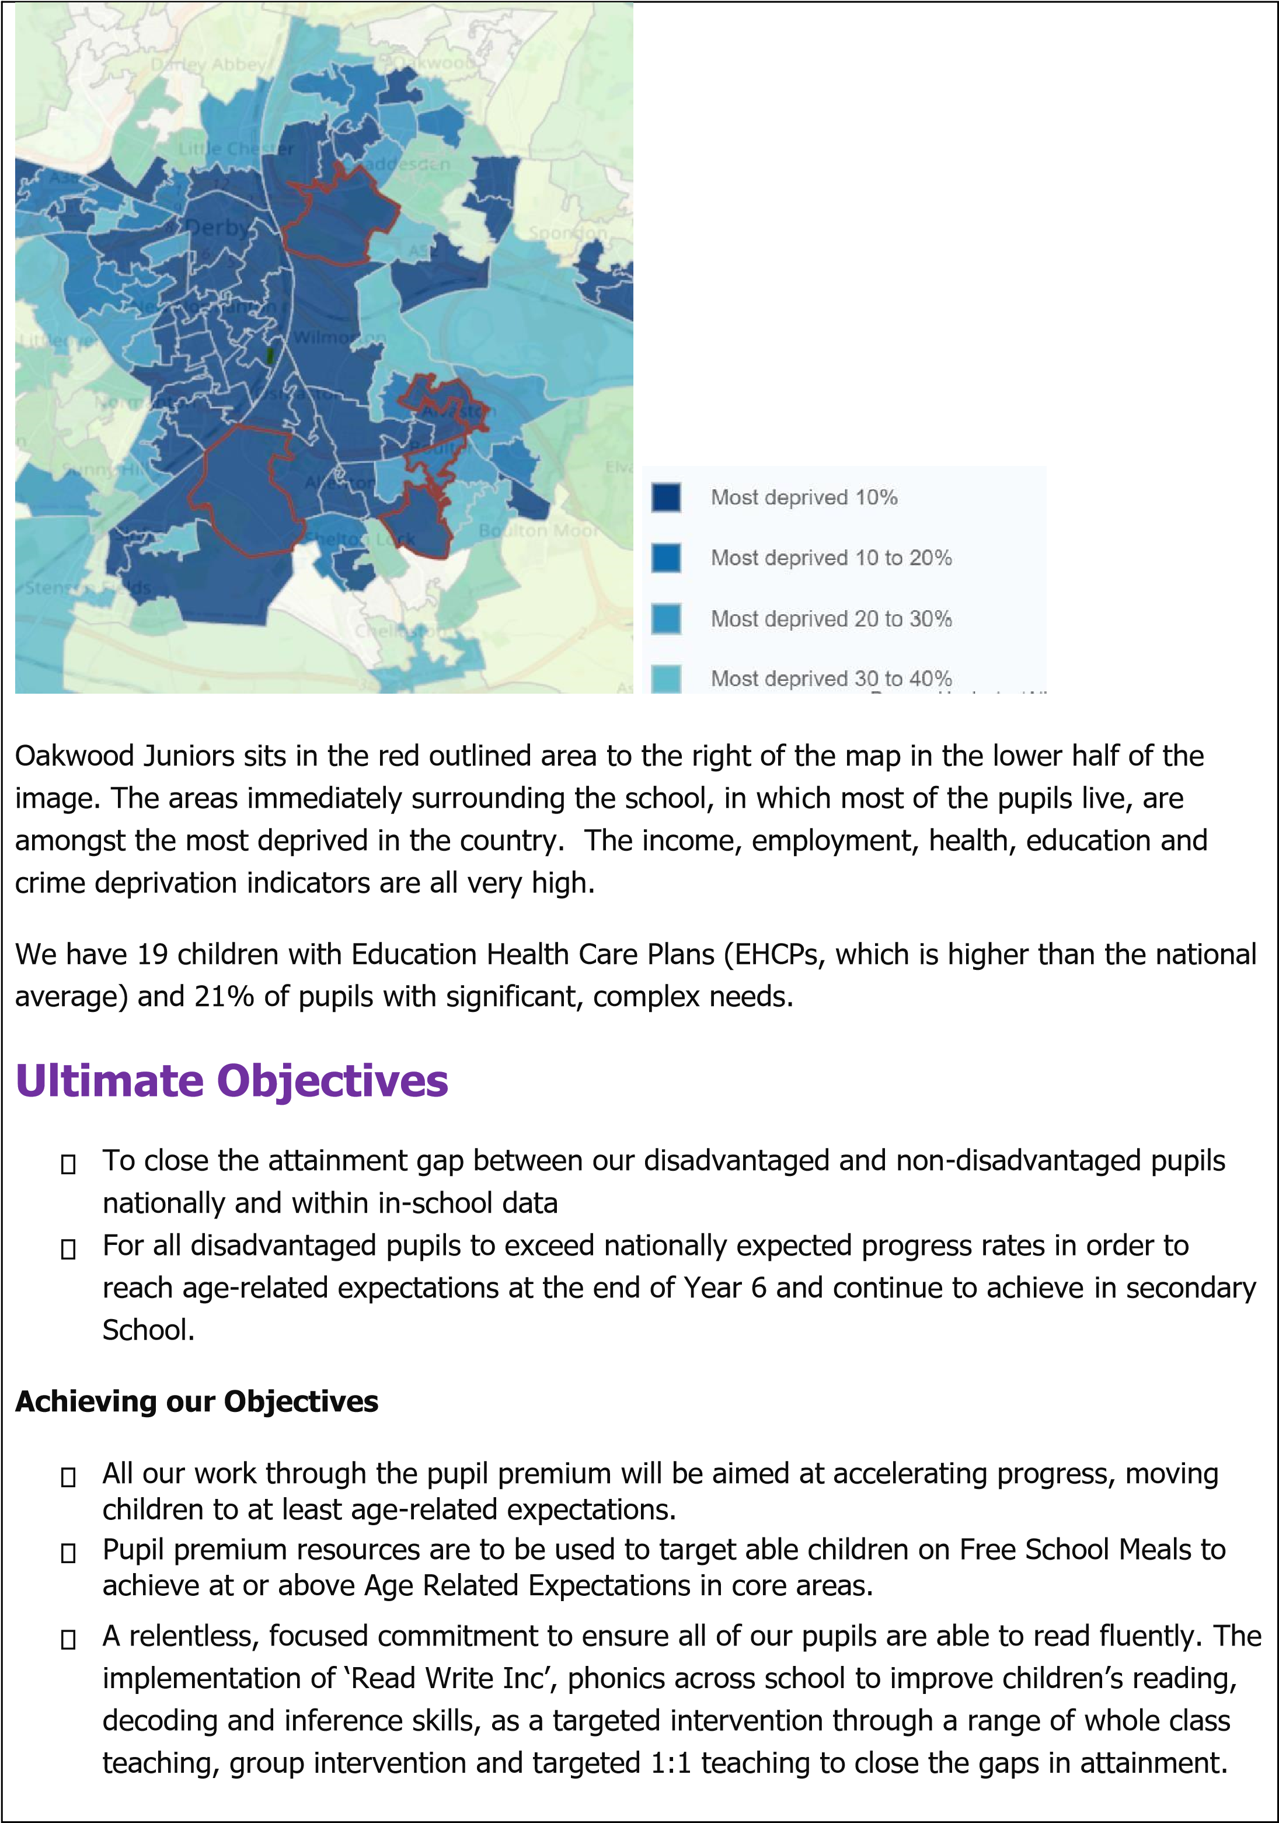
- Additional learning support through the use of well-trained professionals, for all year groups to enable enhanced levels of scaffolding in teaching and learning
- Opportunities for all children to learn how to play an instrument and/or sing as part of a choir – increasing the cultural capital in school
- Plan a range of visits, trips and visitors to school to enhance pupils’ interests, aspirations and knowledge of the wider world and improve their ‘lived’ experiences at school
- Enhanced reading resources across school ensuring high-quality books to captivate pupils’ interests as well as specifically providing a wide range of appropriate decodable texts for pupils accessing Phonics interventions
- Support social and emotional development of our most vulnerable, disadvantaged pupils
- Improve the attendance and punctuality of all pupils and provide Early Help to our families enabling pupils to attend school
- Ensure Quality First Teaching through the provision of high quality and wide-ranging CPD linked to the School Improvement Plan and Staff Performance Management.
- Provide breakfast to our disadvantaged and vulnerable pupils to prepare them to be able to focus and learn.
- Increase pupils’ oracy via use of ‘Voice 21’ initiative and outdoor learning via implementing a program of ‘Forest Schools initiative’, for pupils to experience a wide range of opportunities e.g. building a ‘camp-fire’, roasting marshmallows etc.

This list is not exhaustive and will be adapted and led by pupils’ needs, according to the changing requirements of our Disadvantaged children.
To ensure that our strategy is effective, we will aim to:
- Ensure early identification so that intervention is timely and effective
- Monitor all interventions closely to ensure they are effective and having a positive progress impact upon our disadvantaged pupils
- Ensure a positive, fully-inclusive whole-school approach in which all staff are aspirational and share the same high expectations for all Disadvantaged pupils, foster a ‘no-excuse’ culture i.e. that all children can succeed.

The strategy is a working document and changes have been made to build further upon the provision in place.

Challenges
This details the key challenges to achievement that we have identified amongst our disadvantaged and vulnerable pupils.
Challenge number | Detail of challenge
1 | Impact of Covid 19  Our assessments, conversations with pupils and families alongside observations (supported by several national studies) suggest that the education of many of our Disadvantaged pupils has been impacted by the partial school closures to a greater extent than Non-Disadvantaged pupils. This is due to a range of reasons which have been identified earlier and continues even at present (November 2024). The pupils have been affected academically and emotionally:  - Academic  Analysis of pupil voice and teacher assessments shows that our Disadvantaged pupils can struggle with their learning due to a lack of previous experiences and a lack of support from home as well as some chaotic ‘lived experiences’ in their homes.  This, alongside the loss of opportunities to develop metacognitive skills, can subsequently lead to disengagement and less progress than their non-disadvantaged peers. Many of our disadvantaged pupils did not engage in their remote learning despite regular telephone / online contact with staff.  - Mental Wellbeing  Pupil and parent voice and teacher observations shows that Disadvantaged pupils have felt the most impact on their mental health and wellbeing from the lockdowns. There is evidence of an increase in pupils’ facing challenges in self-regulation of their mental well-being, parents are finding this particularly difficult e.g. reluctance of pupils to attend school.
2 | Reading and Oracy  Assessments, observations and discussions with pupils indicate that Disadvantaged pupils generally have a lower reading age and comprehension skills than that of their peers with some pupils telling us that they do not have any books at home. Monitoring of pupils has also highlighted a significant vocabulary gap between Disadvantaged and Non-Disadvantaged pupils which again has an impact upon reading skills, as lack of background vocabulary at tiers 2 and tier 3 means that pupils need to familiarise and decode these to gain access to a text.  A substantial lack of phonics awareness has been identified at the start of this year in Year 3 with 35 pupils, 43% of the cohort, displaying significant gaps in their phonics knowledge. This is having a real impact on pupils’ decoding which in turn is preventing fluency and acquisition of comprehension skills as the pupils are spending a considerable time learning how to decode. This extended decoding mileage prevents the acquisition of disciplinary knowledge.  In Year 6 we have pupils who missed Year 1 and Year 2, who are still catching up with developing secure phonological knowledge. School is using the PPG to fund a Reading teacher.
3 | Writing  Our assessments indicate that writing attainment amongst our Disadvantaged learners with 67% pupils achieving the expected writing age in comparison to their National peers of 59% (July 2024) but underperform against the non-disadvantaged – nationally 78%.  Again this is an area in which we have introduced new strategies through a new curricular approach which has an increased focus upon Reading, hence both strands interweave.

4 | Mathematics  Our assessments indicate that mathematics attainment of our Disadvantaged pupils (58% at or above age-related expectations in comparison to 73% of Non-Disadvantaged pupils.
5 | Attendance and Punctuality issues  School attendance is below national average (93.5%) overall, from analysis of data we know that the attendance for Disadvantaged pupils and SEND pupils is below their Non-Disadvantaged peers. Persistent absenteeism data aligns with this too.
6 | Chaotic family lives with Social Care Involvement; limited opportunities of life experiences  A majority of our pupils do not have many opportunities to visit museums, the library etc. There is a high level of anti-social behaviour in a significant number of families and social care involvement is wide-ranging too including domestic violence, neglect, substance mis-use, parenting issues, young carers.  We have 8 pupils with Special Guardianship Arrangements and 1 pupil in the looked after category. We have started to note an increase in self-harming in our pupils too as well as a reluctance to attend school, but to want to access technology at home instead i.e. access games like ‘Fortnite’ etc.  The above depicts the complex nature of our pupils ‘lived’ experiences, hence it is crucial that we address these through careful and precise expenditure of our Pupil Premium Grant.
7 | Self-Regulation / Learning Behaviour difficulties  Our school has a large number of pupils with complex and challenging needs that exhibit extremely challenging behaviours at times too.  The majority of these pupils have difficulty in socio-emotional regulation and require constant deployment of strategies/interventions to enable them to regulate their emotions / behaviours to enable them to access learning.  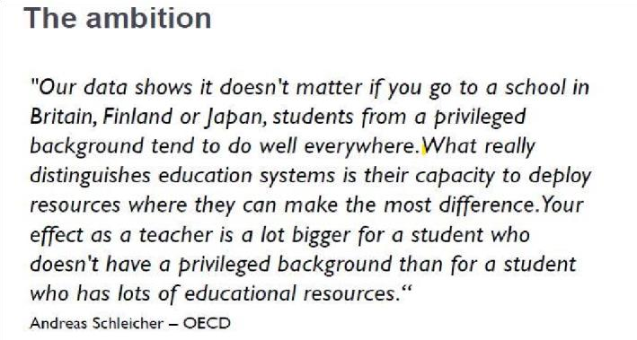

Intended outcomes
This explains the outcomes we are aiming for by the end of our current strategy plan, and how we will measure whether they have been achieved.

Intended outcome | Success criteria
Increase in Attendance | - Absence rate for all pupils is reduced to align with National data  - Persistent Absenteeism of all pupils to reduce for Disadvantaged pupils  - Rigorous monitoring of attendance by Head teachers and Pastoral lead, working with Education Welfare Officers (EWO) for Disadvantaged SEND and non-SEND pupils  - Appointment of Attendance Officer to raise profile and mitigate absenteeism
Increased engagement, improved metacognitive and self-regulatory skills.  Provide a wealth of experiences to improve ‘lived experiences’ of pupils | - Use of Zones of Regulation leading to effective self-regulation of emotions with improvement in dispositions and attitudes.  - 100% Self-regulated learners able to approach tasks, monitor and evaluate their learning and emotions independently, displaying as confident, resilient individuals who are selfaware about their well-being and health  - Sustained high levels of wellbeing demonstrated by qualitative data from pupil voice, pupil and parent surveys and teacher observations  - Create directory of services to refer Vulnerable pupils/ parents to support wellbeing and introduce a half-termly pastoral newsletter, providing tips and news for families in order to develop self-regulation and well-being.  - Provide high-quality support to parents via Early help.  - Teachers and support staff will plan a wide range of visits, visitors and experiences to inspire and enhance learning making learning more memorable and exciting.  - Children will be exposed to a wide range of social, cultural, enrichment and sporting experiences within and outside of the school day to improve their general knowledge and understanding of their local and wider community and improve Oracy.
All disadvantaged pupils reading fluently | - Full Implementation of systematic Phonics program ‘Read, Write Inc’  - 100% pupils fully confident in decoding using synthetic Phonics program  - End of KS2 Reading outcomes show that more than 75% of Disadvantaged pupils met the expected or above standard.  - End of KS2 Reading assessments demonstrate fluent and confident readers able to navigate different genres with confidence
Improved oracy and increase in enrichment  activities | - All pupils are exposed to carefully planned Tier 1, Tier 2 and Tier 3 vocabulary throughout all areas of the curriculum.  - Targeted pupils receive additional, high quality speech and language therapy and intervention.  - Assessments and observations indicate significantly improved oral language among disadvantaged pupils. This is evident when triangulated with other sources of evidence, including engagement in lessons, book scrutiny and ongoing formative assessment.  - An improvement of the levels of communication and vocabulary with more willingness to participate in class discussions and answer questions.  - Increased level of engagement in peer talk with use of expansive vocabulary.  - Parents are engaged in the development of their child’s speech and language.
Disadvantaged pupils make at least expected progress from their individual starting points in Reading, Writing and Maths. | - Disadvantaged pupils achieve above national average progress scores at end of KS2 in Reading, Writing and Maths.  - End of KS2 Maths and Reading outcomes show that 78% of Disadvantaged pupils meet EXS.  - End of KS2 Writing outcomes show that 75% of Disadvantaged pupils meet the EXS  - Narrowing of Gap between Disadvantaged and non-disadvantaged pupils

Activity in this academic year
This details how we intend to spend our pupil premium, this academic year to address the challenges listed above.

Activity | Evidence that supports this approach | Challenge number(s) addressed
Purchase of DfE validated Systematic Synthetic Phonics books to secure stronger phonics teaching for all.  (£4137 – Decodable books) | Supported by the EEF, phonics approaches have a strong evidence base vthat indicates a positive impact on the accuracy of word reading, particularly disadvantaged pupils.  https://educationendowmentfoundation.org.uk/educationevidence/teachinglearning-toolkit/phonics | 1, 2, 7
Purchase of new high-quality books in our Zone of Proximal  Development (ZPD)  Range  (£4268) | Supported by the OU, regularly refreshed, up-to-date texts for the children to read are purchased throughout the year so that there is a continual set of new ‘Texts to tempt’ available. https://ourfp.org/findings/ | 1, 2
Improving oral skills through whole-class teaching using Tier  1, 2 and 3 vocabulary.  Specific planning to enable acquisition of  disciplinary  vocabulary – Tier 3  £1500 – Voice 21 | Continuing whole school CPD on supporting pupils to develop their oral skills through whole-class questioning, display of Tier 3 vocabulary for discussion activities / strategies. All students encouraged to develop active listening and communicating with peers and adults, as well as orally rehearsing using full sentences which ideally will help support the children’s written content.  Oral language interventions | EEF  (educationendowmentfoundation.org.uk)  The Art & Science of Teaching Primary Reading Chris Such Reading – Primary Colour (home.blog)  There is a strong evidence base that suggests oral language interventions, including dialogic activities such as high-quality classroom discussion, are inexpensive to implement with high impacts on reading:  Oral language interventions | Toolkit Strand | Education  Endowment Foundation | EEF  Membership of Voice 21 | 1, 2, 3 and 7
Freckle (£3,316) | It is recommended that technology can improve the quality of explanations and modelling, improve the impact of pupils’ practice and provide robust and analytical assessment. All students are assessed half termly and are also encouraged to engage in practise at home as part of the homework set in order to obtain a higher level of engagement in practise of maths skills from both pupils and their families.  https://d2tic4wvo1iusb.cloudfront.net/eefguidancereports/digital/EEF_Digital_Technology_Guidance_Report.pdf | 1 and 4
Accelerated Reader and MyOn (£13,500) | It is recommended that technology can improve the quality of explanations and modelling, improve the impact of pupils’ practice and provide robust and analytical assessment. All students are assessed half termly which allows us to both monitor progress and ensure that the children are constantly reading texts at their reading age level of challenge. Pupils engage in quizzes on their reading books when they are finished: providing regular opportunities to practise applying their comprehension skills. Pupils are also encouraged to engage in practise at home as part of the homework set in order to obtain a higher level of engagement in practise of reading skills from both pupils and their families. https://d2tic4wvo1iusb.cloudfront.net/eef-  guidancereports/digital/EEF_Digital_Technology_Guidance_Report.pdf | 1, 2, and 3
Picture News Ltd  (£300) | Assemblies and in class discussions on weekly current affairs provide the children with updated topical knowledge about the most important global news, enhancing their cultural capital and providing pupils with purposeful opportunities to develop their oracy skills.  https://www.picture-news.co.uk/ https://oracy.inparliament.uk/sites/oracy.inparliament.uk/files/20 2104/Oracy_APPG_FinalReport_28_04%20%284%29.pdf | 1, 2, 3 and 6
Power of 2 (£600) | Regular 1:1 short sessions based on the progression of key skills in mathematics provide the children with connections between the taught processes in maths lessons and the interventions alongside ensuring that the children do not miss out on other aspects of the curriculum which is a threat of other interventions. https://d2tic4wvo1iusb.cloudfront.net/eef-guidancereports/maths-ks-23/KS2_KS3_Maths_Guidance_2017.pdf (section 7) | 1, 4, 7
Voice 21 (2,600) | Program to improve Oracy across the school.  https://oracy.inparliament.uk/sites/oracy.inparliament.uk/files/20 2104/Oracy_APPG_FinalReport_28_04%20%284%29.pdf  An intervention that weaves oracy into school’s curriculum. | 1,2,3 and 6

ELSA TRAINING : SPRING 2025 - £1200 – TO FOCUS UPON EMOTIONAL REGULATION

Targeted academic support (for example, tutoring, one-to-one support structured interventions)
Budgeted cost: £140,600
Activity | Evidence that supports this approach | Challenge number(s) addressed
Additional phonics (including Fresh Start) sessions targeted at disadvantaged pupils who require further phonics support. This will be delivered in collaboration with our local English hub to deliver a researchinformed approach  (https://www.flyinghighpartnership.co. uk/eng lish-hub). | Phonics approaches have a strong evidence base indicating a positive impact on pupils, particularly from disadvantaged backgrounds. Targeted phonics interventions have been shown to be more effective when delivered as regular sessions over a period up to 12 weeks as described in: https://educationendowmentfoundation.org.uk/educati onevidence/teaching-learning-toolkit/individualisedinstruction | 1, 2 and 3
School-led tutoring for pupils whose education has been most impacted by the pandemic. A significant proportion of the pupils who receive tutoring will be disadvantaged, including those who are disadvantaged but high-attaining. (£25,000 = 2 teachers in 2 different year groups focusing upon supporting the most Vulnerable pupils in their learning.) | Tuition targeted at specific needs and knowledge gaps can be an effective method to support low attaining pupils or those falling behind, both one-to-one:  One to one tuition | EEF (educationendowmentfoundation.org.uk) And in small groups:  Small group tuition | Toolkit Strand | Education  Endowment Foundation | EEF  Government guidance on using recovery premium funding: schools should spend this premium on evidence-based approaches to supporting pupils. In line with the Education Endowment Foundation’s pupil premium guide, activities should include those that provide targeted academic support, such as tutoring.  https://educationendowmentfoundation.org.uk/educati onevidence/teaching-learning-toolkit/one-to-one-tuition | 1, 2, 3, and 4
Additional support staff  (£45,000)  2 additional Learning Support  Assistants to support gaps in learning and provide additional interventions to support pupils in their learning and to regulate behaviours. | https://d2tic4wvo1iusb.cloudfront.net/eef-  guidancereports/send/EEF_Special_Educational_Needs_in_Mains tream_Schools_Guidance_Report.pdf  https://d2tic4wvo1iusb.cloudfront.net/eef-  guidancereports/teachingassistants/TA_Guidance_Report_Making  BestUseOfTeac hingAssistants-Printable_2021-11-02-  162019_wsqd.pdf  Additional staff recruited to support interventions, narrow the gap in attainment in all areas, most specifically Phonics and Reading. Also to support SEND pupils to regulate behaviour and support with providing pastoral support especially in mornings when receiving pupils into school. | All areas
2 Additional support teachers for focus upon disadvantaged SEND (£68,000)  1 additional specialist teacher to support SEND pupils in learning and provide additional interventions to support pupils in selfregulation behaviours. | https://d2tic4wvo1iusb.cloudfront.net/eef-  guidancereports/send/EEF_Special_Educational_Needs_in_Mains tream_Schools_Guidance_Report.pdf  Support SEND pupils to regulate complex behaviours and provide pastoral support especially in mornings when receiving pupils into school. | All areas

Wider strategies (for example, related to attendance, behaviour, wellbeing) Budgeted cost: £82,443
 | Activity | Evidence that supports this approach | Challenge number(s) addressed
 | Forest School  Learning  (£5016 per annum) | Regular opportunities for children to work collaboratively with their peers towards a common goal or challenges supports raising and attainment and developing resilience.  https://educationendowmentfoundation.org.uk/educationevidence/teachinglearning-toolkit/collaborative-learning-approaches  Forest school sessions have been proven to have positive impacts on pupil resilience, confidence and wellbeing and is proven to improve pupil’s oral and language skills.  Microsoft Word - long term Forest Schools and Reilience, Wellbeing and  Confidence - Quantitive Reseach [v2].doc (wordpress.com) | 1,2, 6 and 7
 | Zones of Regulation  (£500) | Explicitly teaching self-regulation strategies to all pupils is an inexpensive method to become independent, resilient learners with a great impact on mental health and wellbeing. Regular CPD is be integral to the success of the programme. https://d2tic4wvo1iusb.cloudfront.net/eef-guidance- reports/metacognition/EEF_Metacognition_and_self-regulated_learning.pdf | All areas
 | Behaviour Support via  LA Specialist from Newton’s Walk | https://d2tic4wvo1iusb.cloudfront.net/eefguidancereports/behaviour/EEF_Improving_behaviour_in_schools_Report.pdf  Behaviour Panel involved in discussing most challenging behaviours of SEND pupils and support from Local Authority Behaviour Support | All areas
 | Learning Support  Assistant  (£19,340) | https://d2tic4wvo1iusb.cloudfront.net/eef-guidancereports/primarysel/EEF_Social_and_Emotional_Learning.pdf  More frequent behaviour difficulties meaning PP pupils are more likely to be unprepared emotionally which impacts on their academic progress. However new interventions are demonstrating an impact on behaviour incidents allowing pupils to regulate their emotions and visualise their emotions via images and appropriate vocabulary – displayed in their learning environments.  With the additional increase in STePs involvement in this intervention, it is essential that we can spot triggers which will affect learning. | 1 and 7
 | Counselling | There is extensive evidence associating childhood social and emotional skills with improved outcomes at school and in later life (e.g., improved academic performance, attitudes, behaviour and relationships with peers):  EEFSocial_and_Emotional_Learning.pdf educationendowmentfoundation.org.uk | All areas
 | Work with EWO  & EHA support with parents. Approx. 2 hours per  week Monthly EWO sessions  £4,097  £12,500 | Evidence from Education Endowment Foundation –  Teaching and Learning Toolkit: Parental Engagement (+ 4 Months.)  Parental engagement | EEF  (educationendowmentfoundation.org.uk)  Attendance is crucial and statutory, EHA provision to support parents in bringing their children to school.  EWO support to address absenteeism: Parental engagement | EEF  Recruitment of Attendance Officer – one term only in this academic year | All areas
 | Relate – Safe Speak  Counselling (£6,000) | There is extensive evidence associating childhood social and emotional skills with improved outcomes at school and in later life (e.g., improved academic performance, attitudes, behaviour and relationships with peers):  EEF:Social_and_Emotional_Learning.pdf(educationendowmentfoundation.org.uk | All areas
M&M Theatrical  Productions (£3,200)  Experiences  (including watching a live show twice every years. Dance Workshops (£599) |  | Pupils have access to a rich array of experiences to build cultural capital. This improves Oracy and wellbeing.  Research shows too many young people from disadvantaged backgrounds never get the chance to engage with extra-curricular activities.  https://assets.publishing.service.gov.uk/government/uploads/syst  em/uploads/attachment_data/file/818679/An_Unequal_Playing_Field_report.pdf | 1,2,6 and 7
STEM: Investigative work: role play  (£1800) |  | Research shows too many young people from disadvantaged backgrounds never get the chance to engage with extra-curricular activities.  https://assets.publishing.service.gov.uk/government/uploads/syst  em/uploads/attachment_data/file/818679/An_Unequal_Playing_Field_report.pdf | 1
Music tuition: Teaching of handbells/ Recorders  / Ukeleles /Music hub  (£22, 000) |  | Every child has the right to learn to play an instrument  All children, including those from disadvantaged backgrounds, deserve a wellrounded and culturally rich education. The EEF are partnering with the RSA and others to help add to the evidence base in this important area.  https://educationendowmentfoundation.org.uk/news/newpartnership-to-test-theimpactof-different-cultural-learningstrategie | 1, 6 and 7
Opportunities for in school and after school clubs e.g. Journalism Club, Gardening, Reading Clubs, Sports Clubs all year round. All clubs free to pupils or heavily subsidised.  Payment of staff:  £500 |  | This research highlights the importance of after school clubs for increasing disadvantaged children's access to activities and explore what it is about how these clubs are structured and delivered that helps to engage less affluent families. https://eprints.ncl.ac.uk/file_store/production/232456/3BDEE6A8646B4EE8-B01FED0C672C21C6.pdf | 1, 6 and 7
Bagel Breakfast £1498 |  | Research shows that cognitive function is affected by lack of breakfast, due to the negative impact upon attention, memory and attention time; school has started providing bagels for breakfast for all pupils.  The impact of breakfast on learning in children - Family Action (familyaction.org.uk)
Reading intervention teacher |  | The teacher will provide support to pupils to become fluent in their reading to enhance their comprehension skills | 1 and 7
SEND teacher |  | The teacher provides support and intervention to pupils with SEND to support cognitive ability and support with regulation | 1 and 7

Total budgeted: £252, 964

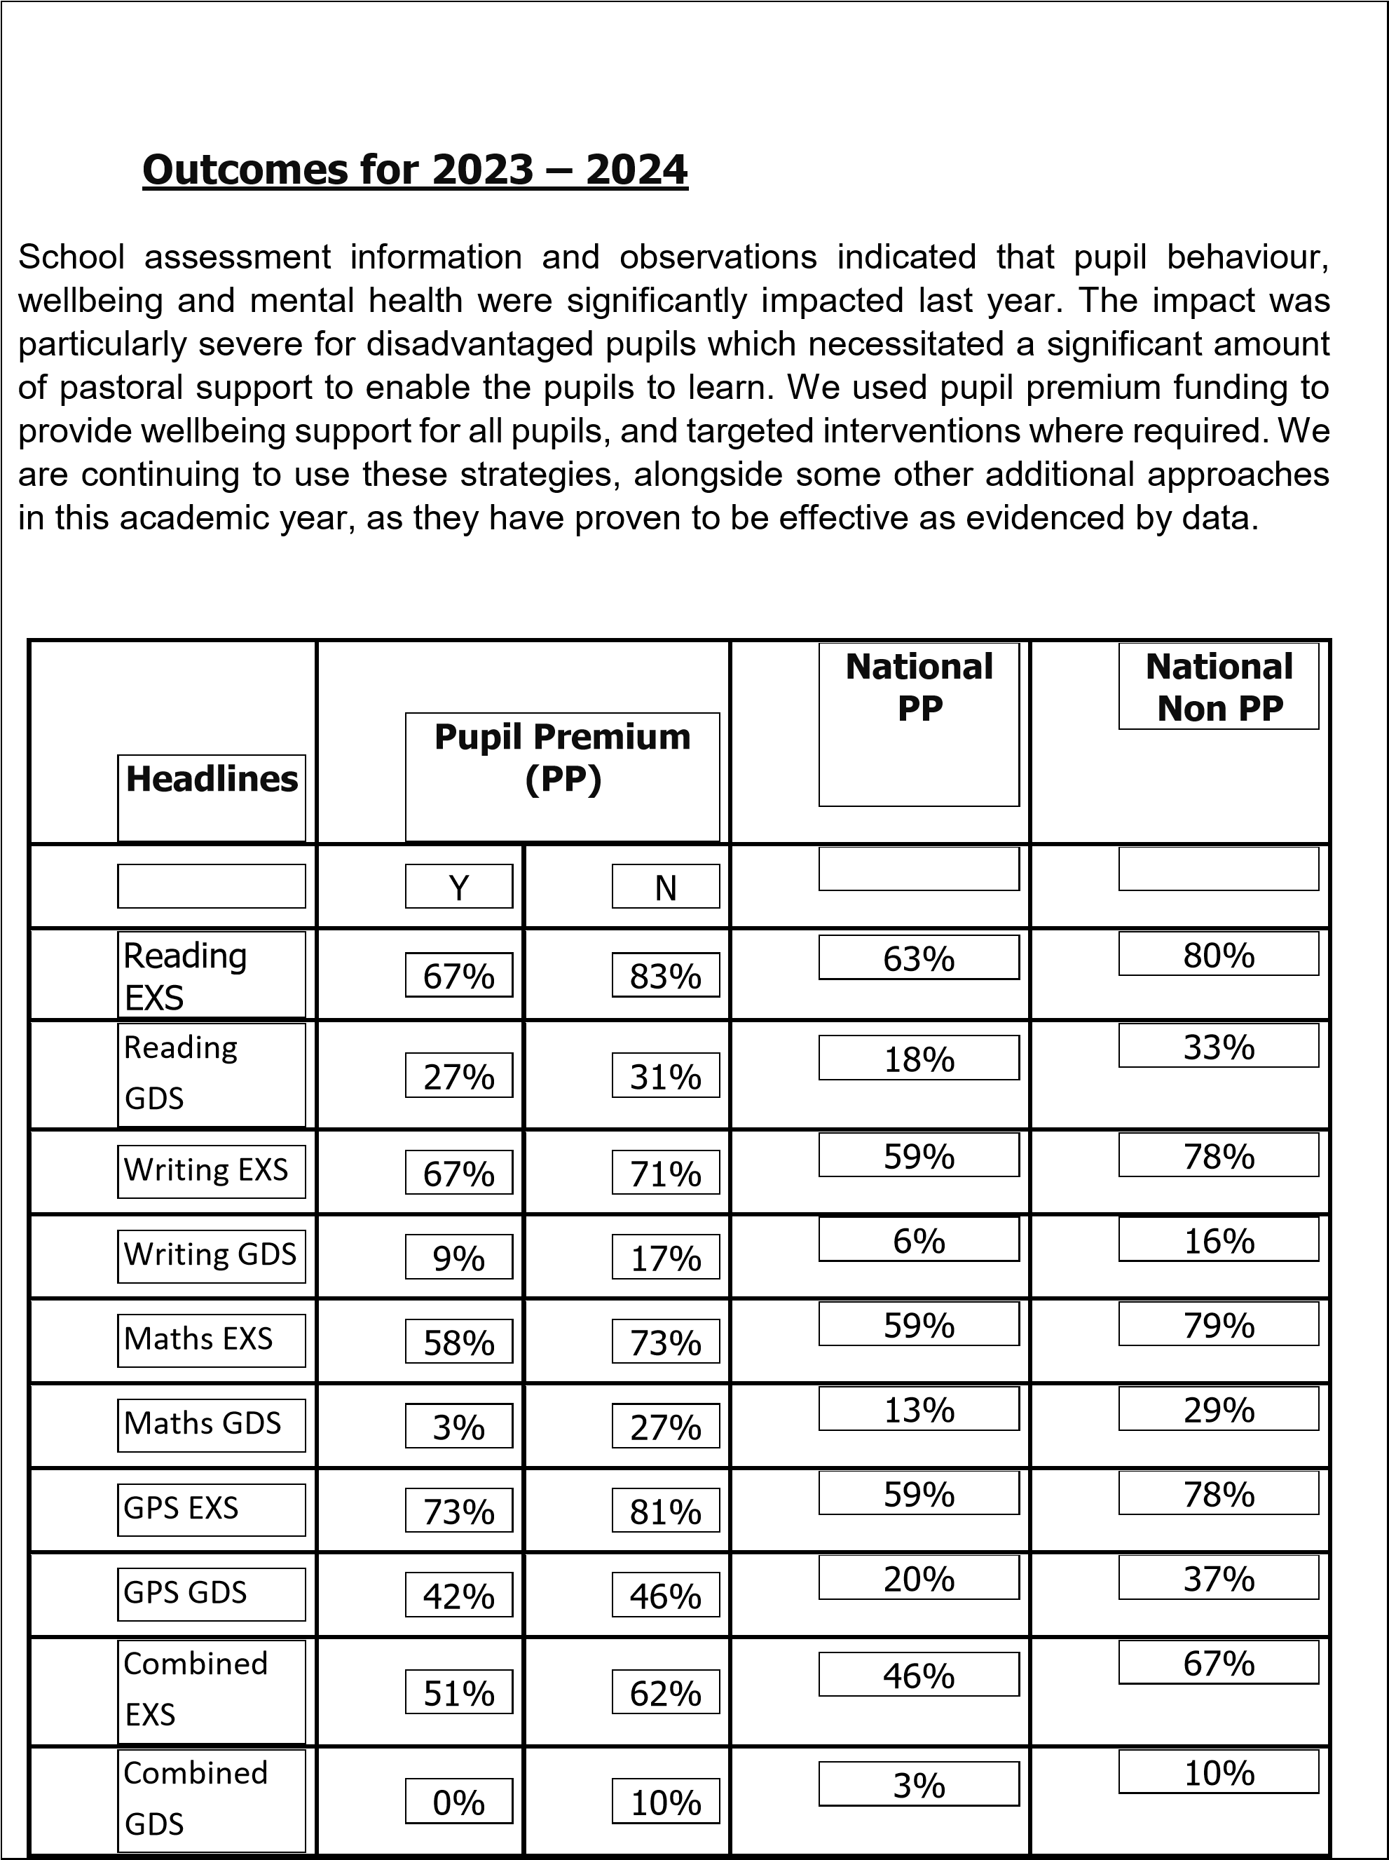

Externally provided programmes
Programme | Provider
Pivats | Connecting Steps
Oddizzi | Geographical Association
Read, Write Inc | Ruth Miskin
Times Tables Rock Stars | Maths Circle Ltd
Tig Tag World | Twig Education
Zones of Regulation | Social Thinking, Inc
Specialist PE Training | Derby County Community Trust
MyOn, Accelerated Reader and Freckle | Renaissance
Subject Associations e.g. PSHE,  Geography, History | National Associations
Power Maths | Pearson
Voice 21
Picture News

PP = Pupil Premium
EXS = Expected Standard
GDS = Greater Depth Standard
Combined = Reading, Writing and Maths
33/85 pupils = Pupil Premium = 39% (2023 – 2024)

