

WELLBEING NEWSLETTER
July 2023 Transition
Summer Activities
23 July – Alvaston Park Community Fun Day Something for the whole family to enjoy! A fun-packed day for all including live music, dancers, a dog show, fair rides, and craft and charity stalls. There will also be a selection of food and drinks, face painters, characters and model boats.
12-13 August Markeaton Park Food and Drink Festival 10:30-4:30pm. Enjoy street food, bars, artisan stalls, gifts & craft stalls & entertainment.
13 August – Makeney Hotel Princess and Superhero Fun Day and Lunch (12:45-3:30pm). Coming to our hotel this August!! Sunday 13th! Bring your Princesses and superhero's to meet our Princesses and superhero's attending our fun day including Lunch, it will be a blast! Contact the events team to get tickets 01332 845704 or events@makeney.co.uk
26-27 August British BMX Championship 2023 Alvaston Park. Riders will return to Derby for the 2023 edition of the British BMX Championships, where reigning champions Beth Shriever and Quillan Isidore will look to defend their titles.

We know parenting isn’t always easy. Although it’s often amazing and rewarding to watch your children grow up, and to help them learn to be independent, it can also be really hard work.

Whether a child or young person is starting primary school, secondary school, further education, changing schools, or leaving school for university or work, this transition period needs to be carefully managed. If a child struggles with a transition it can have a negative impact on their wellbeing and academic achievement.
During any transition period, it’s important that children and young people are able to talk about their concerns and are supported to cope with any readjustments. There are lots of things that education settings can do to help pupils prepare for, and cope with, change - and also build resilience, self-confidence and self-esteem.
Engage with parents and carers - Parents and carers are often key to making sure that a child or young person has a good transition to a new school or college. A few things that parents, carers and teachers can do include:
- checking in with the child or young person to find out how well they are coping academically, but also in terms of their wellbeing
- keeping an eye on how they are socialising, if they are making friends and hanging around in positive peer groups
- providing opportunities for parents and carers and staff to link up.
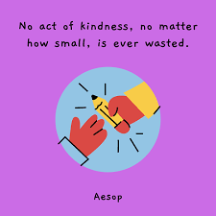
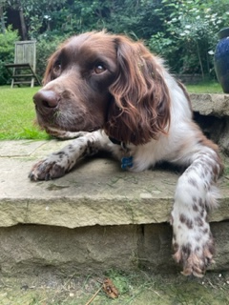
Enjoying the Outdoors
During the holidays Ron will be walking, running and sniffing all over Derbyshire and probably further afield. He will be swimming and getting covered in sticky buds and twigs. Ron loves spending time outside – when you’re back in September please tell him where you’ve been enjoying the outdoors.

