

WELLBEING NEWSLETTER
February 2023
COMPASS
At Oakwood Junior School we regularly refer children to Compass, previously Action for Children. They can help children build their skills to cope with: Low mood; sadness, low motivation; Mild to moderate anxiety; worries, irrational fears and concerns; Common challenging behaviours: angry outbursts, pushing boundaries, frustration and distress Family and peer relationship difficulties; Difficulty adjusting to change and transition; Difficulty managing emotions.
They provide low intensity CBT in either one-to-one or group setting (usually 6-8 sessions based on what you need) for children and young people aged 5-18.
The service is made up of Education Mental Health Practitioners, Mental Health Practitioners and Supervising Practitioners from a range of health and education backgrounds.
If you think they could support your child, either speak to Mrs Fray in school or phone 01332315569 and speak to one of the team.
Supporting Children with Anxiety
Ways to help a child who’s struggling include:

- Letting them know you’re there for them and are on their side
- Try talking to them over text or on the phone if they don’t feel able to talk in person
- Being patient and staying calm and approachable, even if their behaviour upsets you
- Recognising that their feelings are valid and letting them know it’s okay for them to be honest about what it’s like for them to feel this way
- Thinking of healthy ways to cope you could do together, like yoga, breathing exercises or mindfulness
- Encouraging them to talk to their GP, someone at their school or Childline. Especially if they’re finding it hard to talk at home.
- Take care of yourself and get support if you need to. Try not to blame yourself for what’s happening and to stay hopeful about your child’s recovery.
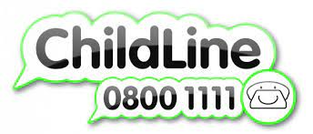
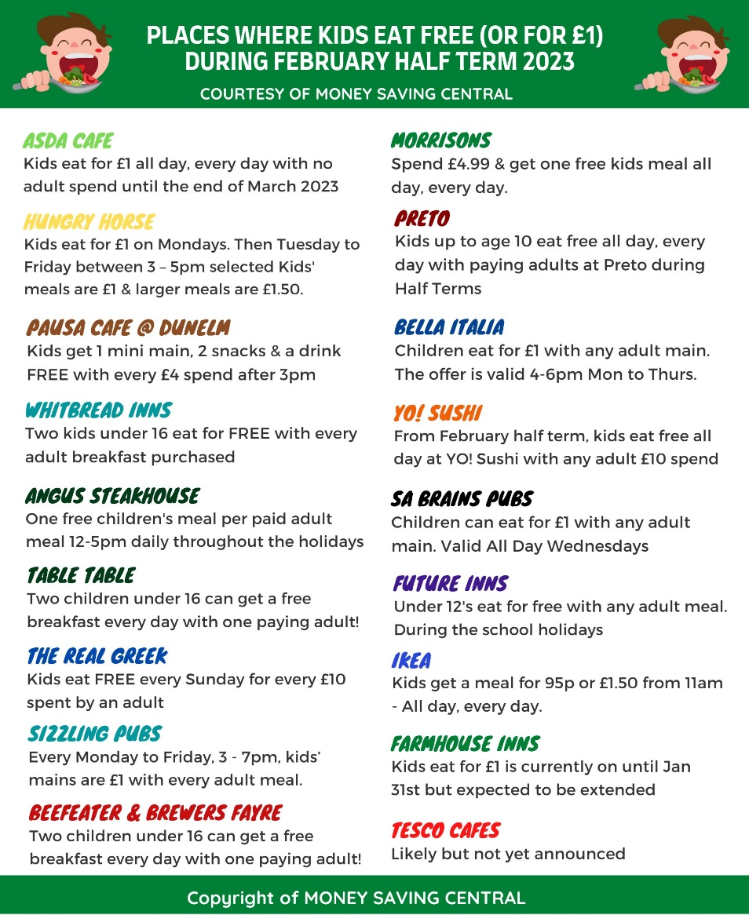
- Pop into to school and ask for a referral to Compass.
Things to do in half term
-Museum of Making – 23rd February. Free: make clay sea life creatures. Booking recommended. https://www.ticketsource.co.uk/derby-museums/t-rpzmylg
-Normanton Library – just £3 per show, per child. ‘Curious Investigators’ Wed 22nd Feb.
- Half price activities at Derby Arena. Table tennis or badminton between 8am and 4pm.

