
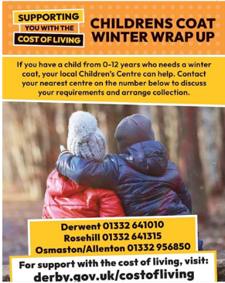

Parent
WELLBEING NEWSLETTER

Merry Christmas and Happy New Year
The festive season is a time for joy and being with our loved ones.
All of us at Oakwood Junior School wish you a warm and joy filled holiday.

However, for some, this time of year can be difficult as we remember those who are no longer with us to share our celebrations. Christmas 2022 will be especially difficult for those people who have financial hardship deciding between gifts, food and heating homes.

Life Links provides a wellness and mental health recovery service. They offer information, advice and navigation services which can help you find community and digital resources that will help you to achieve your recovery outcomes, make your independence more sustainable and support you in developing your own support networks. For more information contact: derbycitylifelinks@richmondfellowship.org.uk

Things to do with the family
Festive Light Projections (8th December 2022 - 31st December 2022) Working in partnership with QUAD, the Cathedral Quarter will be lit up with a number of lighting projections in the area. Festive images will be beamed onto buildings in Sadler Gate, Friar Gate, The Market Place and Derby Cathedral to name a few!
Advent Trail at Kedleston Hall (8th December 2022 - 31st December 2022 Free event, admission applies) Fun for all of the family. The trail along the surfaced 'short walk' path will lead you to find 25 doors for advent. Open each one for a festive challenge, question or discovery. Dogs on leads welcome (one for Ron!).
Little Eaton Advent Windows – (1st Dec until at least 1st January). People all around the village have volunteered to be part of the second living advent calendar. A new window each day is unveiled during the advent period.
The Changing Lives Service is part of a national trailblazer project, funded by the Government as part of its ambitious plans to transform children and young people’s mental health as cited in the NHS Long-Term Plan.
Anxiety: How you can help your child - with five simple coping techniques
“Anxiety evolved to protect us. It’s generated by our primal brain, which has the job of keeping us safe and out of danger. Our primal brain constantly scans for danger and as soon as it detects a threat, it floods us with adrenaline, creating physical symptoms such as dizziness, sweating, trembling, nausea and more. This causes the fight/flight/freeze response that people experience when suffering from acute anxiety.” Clinical Psychologist Anna Colton
Top tips are:
Talk to them about it: Give them the vocabulary to name their fears. When they are able to understand them and work through them this will open up brain space and show that others feel the same. Reassure them.
Celebrate success: Celebrating with your child will help them to shift their focus onto their abilities and to feel proud of their successes. This will support their self-esteem.
Put in talking time: Set aside 20 minutes each day to sit down with your child and metaphorically open the worry box to 'see' and discuss their worries. At the end of that time, metaphorically shut the box, locking the worries away in it. Once worry time is over, that’s it until the next day.

Challenge the thoughts: A thought is just a thought. It’s not a fact, and just because you or your child think something, it does not make it true. So, every time that your child tells you their anxious thoughts or worries, validate them and show them you understand, but then challenge the thought.
Distraction: Worries need attention to grow and when we’re distracted, our mind isn’t free enough to give the worries attention, and so they reduce.
If you are still worried talk to school. A referral to Changing Lives can be made: https://services.actionforchildren.org.uk/derbyshire/changing-lives/make-a-referral/

