

Parent
WELLBEING NEWSLETTER
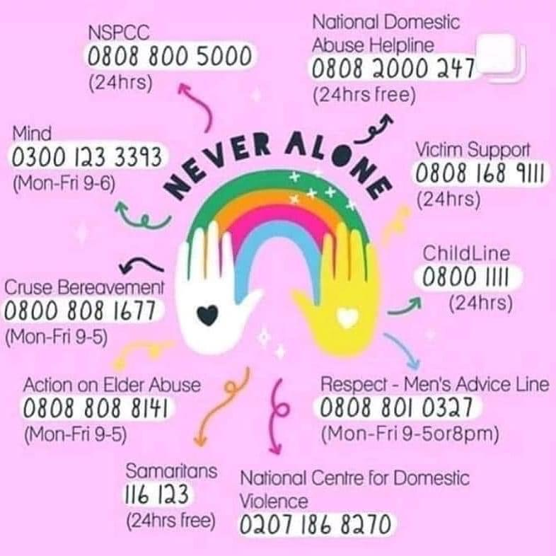
DOMESTIC ABUSE ACT 2021
The Domestic Abuse Bill recognising children as victims of domestic abuse for the first time.
The Domestic Abuse Bill:
- Will see children who live in a home where domestic abuse takes place recognised as victims in their own right rather than witnesses for the first time. The Bill will recognise a child who sees or hears, or experiences the effects of, domestic abuse and is related to the person being abused or the perpetrator is also to be regarded as a victim of domestic abuse.
- Places a duty on local authorities in England to provide support to victims of domestic abuse and their children in refuges and other safe accommodation.
- Increases protections for families affected by domestic abuse under Domestic Abuse Protection Orders and the Domestic Violence Disclosure Scheme.
- Extends victim protections to young people aged 16 and over. In 2020, the minimum age for a person to be classed as a victim of domestic abuse by a partner was lowered to 16 meaning that all elements of the Bill will affect young people above this age. Key elements of the Bill include strengthening rules surrounding controlling or coercive behaviour, target revenge porn and end the "rough sex defence" in court.
- Gives all eligible homeless victims of domestic abuse, aged 16 and above, "priority need" for homelessness assistance.
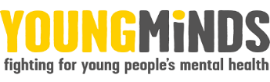
Domestic abuse always has an impact on children. Being exposed to domestic abuse in childhood is child abuse.
Children may experience domestic abuse directly, but they can also experience it indirectly by:
• hearing the abuse from another room
• seeing someone they care about being injured and/or distressed
• finding damage to their home environment like broken furniture
• being hurt from being caught up in or trying to stop the abuse
• not getting the care and support they need from their parents or carers as a result of the abuse (Holt, Buckley and Whelan, 2008).

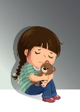
Parenting isn’t always easy. Although it’s often amazing and rewarding to watch your children grow up, and to help them learn to be independent, it can also be really hard work. It can feel especially hard if your child's mood and behaviour seem different and you're not sure why, or what you can do to help. But you are not alone.
‘Young Minds’ have lots of practical advice and tips on supporting your child - from how to encourage your child to open up about their feelings to dealing with mental health services. No matter what you and your child are going through, things can get better.
‘Young Minds’ also have a parent’s helpline which can provide advice and support if you're worried about a child or young person. https://www.youngminds.org.uk/parent

HOLIDAY IDEAS
Erewash Museum, Ilkeston (28th May) - The Vikings are taking over the Museum! Go along and see the encampment, meet a Viking and see some amazing combat displays from the Viking re-enactment society. (Ticket cost)
National Forest Adventure Farm, Burton-on-Trent (28th May-5th June) - Have a roar-some time at the Adventure Farm. Meet there new Raptor Ranch where there is a T-Rex, Velociraptor, Triceratops and Spinosaurus. Learn to tame ferocious beasts in the Dino Training Camp and much more. (Ticket cost)
Pickford’s House, Derby (28th May) - Venture down the rabbit hole with Alice and her Wonderland friends at Pickford’s House!
Family friendly Wonderland inspired entertainment and activities you’d be mad to miss! (£3 for under 13’s, all others free)

