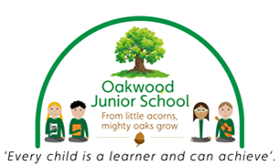
Parent
WELLBEING NEWSLETTER

Welcome to the second Oakwood Junior School ‘Well-Being Newsletter’. The mental health of you and your children are very important to us at Oakwood Junior School. This newsletter will signpost you to mental health agencies and provide you with ideas and activities which help to keep you and your family smiling.
Do good and good will come to you.

HOLIDAY FUN
Just a few ideas to help you have family fun.
22+23/02/2022 – Fire Pit Bake Off at Chatsworth £7.50 per child, £2.50 per adult. For more information: https://www.visitderby.co.uk/whats-on/events/fire-pit-bake-off/

23/02/22 – Art Hub: Faceless Portraits at Derby Museum and Art Gallery – FREE. For further information: https://www.visitderby.co.uk/whats-on/events/art-hub-faceless-portraits/
25/02/22 – Family Friday: And Tango Makes Three at Derby Museum and Art Gallery – FREE. For further information: https://www.visitderby.co.uk/whats-on/events/family-friday-and-tango-makes-three/

What can I do at home?
Find time to talk, just the two of you – ‘Check in’ with them while you’re doing things together, so they get used to talking about their feelings.
Play together – Play helps them to be curious, learn new things, solve problems and express feelings without words.
Be a role-model – Show how you cope with difficult feelings and look after yourself.


If you don’t fancy these try our activity idea sheet (see overleaf).

Self Harm – PUBLIC CONSULTATION
This is a very difficult and emotive topic. According to a major survey from 2017 among 11 to 16-year-olds, 7% of girls and more than 3% of boys are affected. Experts feel the real number is higher as it’s often hidden.
A mental health charity said guidance would empower teachers to support young people. It warned that more mental health support teams in schools were needed. These are the first new guidelines on self-harm produced by the National Institute for Health and Care Excellence (NICE) for 11 years, and a public consultation on the guidance will run until 1 March.

Child Bereavement UK
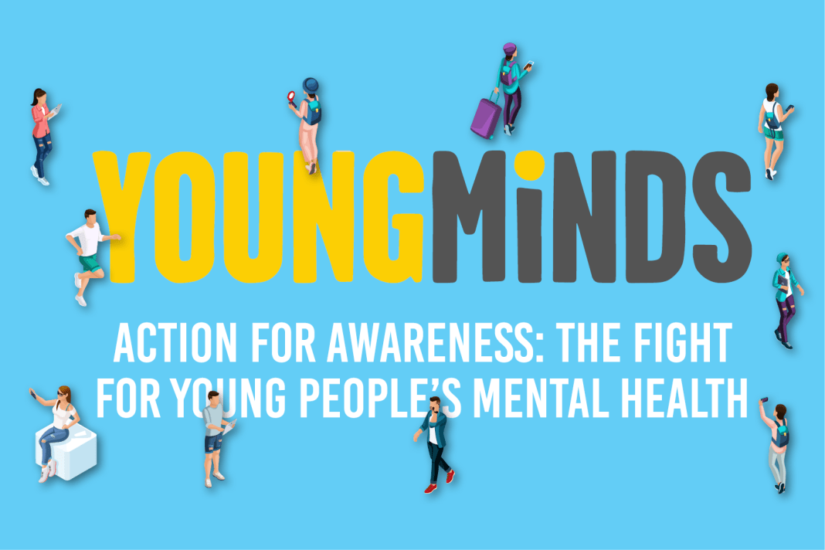
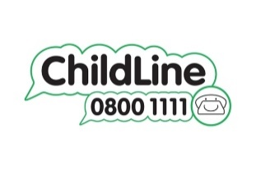
This agency helps children, parents and families to rebuild their lives when a child grieves or when a child dies. They support children and young people up to the age of 25 who are facing bereavement, and anyone affected by the death of a child of any age. They offer free, confidential bereavement support by telephone, video or instant messenger, wherever you live in the UK.
Telephone: 0800 02 888 40
helpline@childbereavementuk.org

