
STAFF WELLBEING NEWSLETTER

Welcome to the very first Oakwood Junior School ‘Well-Being Newsletter’. We value our staff and want to support you in looking after your mental health by signposting you to mental health agencies and providing you with ideas and activities which help to keep you smiling.
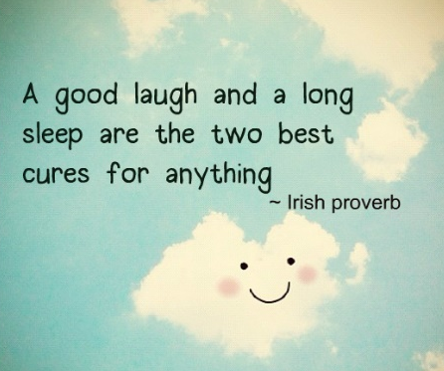
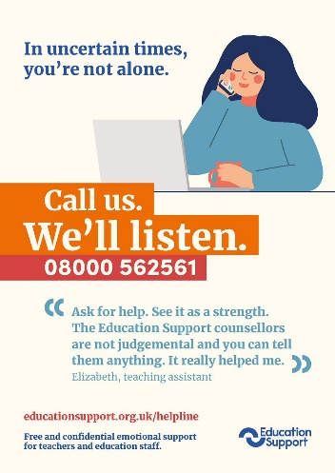
EDUCATION SUPPORT
On this website you will find lots of helpful links, short videos and ideas to support the following areas:

- Anxiety
- Stress
- Burnout
- Working life
- Depression
- Grief or bereavement
- Personal life
Caring for the mind is as important and crucial as caring for the body. In fact, one cannot be healthy without the other.
- Self-care
- Finance
WELCOME TO HEADSPACE FOR EDUCATORS
Headspace offers free access (primary-secondary) teachers and supporting staff.
Whether you’re feeling inspired to connect more with your students or you’re looking for
a new way to bring calm to your classroom, Headspace can help students build healthy
habits that last a lifetime. Better focus, less stress, and happier thoughts are just a few
minutes away.
https://www.headspace.com/educators
red to connect more with your students or you’re looking for a new way to bring calm to your classroom, Headspace can help students build healthy habits that last a lifetime. Better focus, less stress, and happier thoughts are just a few minutes away.



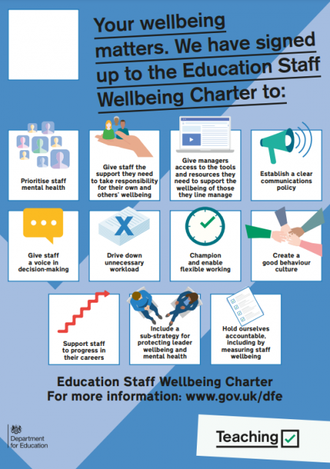
The National Sleep Helpline 03303 530 541
The National Sleep Helpline helps anyone with sleep issues including adults, parents and young people. The helpline is available from 7pm and 9pm, Sunday to Thursday on 03303 530 541.
Having a sleep issue is surprisingly common. At any given time this affects up to 40% of adults and 50% of children (this rises to 80% with a SEND diagnosis).
The education Staff Wellbeing Charter is a declaration of support for, and set of commitments to, the wellbeing and mental health of everyone working in education.
The charter is for education staff in England. This includes temporary and support staff. All state funded schools and colleges are invited to sign up to the charter, as a shared commitment to protect, promote and enhance the wellbeing of their staff.

