Maths
Out units for Maths this half term are:

Measurement – Imperial & Metric
Number - Ratio & Proportion
Number - Algebra

Times Tables– This half term, we will be securing our knowledge of the 9,10,8 and 7 timetables. We will continue with our daily TT Rockstar sessions to practise our timetables fluency.

English
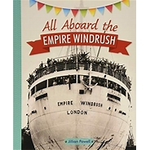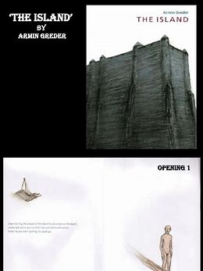
Reading –
In our Reading lessons during Spring 1, we will be looking at the book ‘All Aboard the Windrush’ - a non-fiction book that tells the children information about life on the Windrush along with a diary of a boy called Preston who was on the ship.

Grammar – Our grammar work for this half term will focus on subordinating & co-ordinating conjunctions, simple past tense, simple progressive tense and passive and active voice.

Writing
In Writing, we will be writing on explanatory texts and working towards an adventure story.

History 
Our History unit will be centred on the Windrush generation. The children will look at the following questions:
Where are the Caribbean Islands? What is their history?
How did people in the Caribbean help Britain in the war against Nazi Germany and Hitler?
Why did people migrate from the Caribbean to England in 1948?
What was life in London like for the Windrush pioneers?
Who was Sam King was what did he do?
Who was Norma Best and what did she do?
How did the Windrush migration change Britain for the better?

Year 6 Spring 1
Curriculum Overview

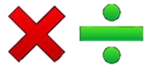
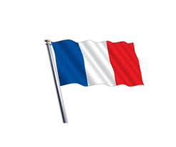
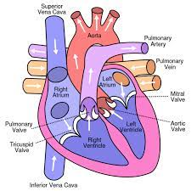
Understanding the Arts
Art:
Pupils will create a simple one-point perspective drawing and use selected parts to create a printed image as well as replicate line through batik. we will look at the work of Patrick Hughes for inspiration.
Music:
During our Music lessons, we will be continue looking at the structure of singing and start to identify cyclic patterns including verse, chorus and coda.

Science – Animals including humans. This half-term we will focus on biology. We will answer the following questions:
What is blood made up of and why do we need it?
Why does our body need nutrients and how are they transported?
What is our circulatory system?
What is our heart like inside and how does it work?
Who influenced what we know about our circulatory system?
What can we do to keep healthy?

RE- In R.E. we will be focusing on answering the question: Is it better to express your belief in arts and architecture or in charity and generosity?
We will also look at Judaism during World Religion Day.

French – Do I have a pet?
Pupils will be able to repeat, recognise and attempt to spell the eight nouns for pets including the correct article, tell somebody if they have or do not have a pet, tell somebody the name of their pet, attempt to create a longer phrase.

PSHE – We will be spending the half term exploring dreams and goals. This will foster resilience, respect and aspiration. We will encourage the children to look for challenges and discuss how to overcome them.
The children will also be working with Derby Schools Sports Partnership to look at fitness and being healthy.
PE – During this half term, for our indoor PE we will be gymnastics – matching & mirroring. Our outdoor PE sessions will be basketball.
Computing – This half term, we will focus our Online Safety learning on ‘Online Relationships’. Our computing learning will focus on designing and creating webpages, giving consideration to copyright, aesthetics, and navigation.



