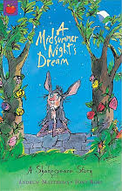
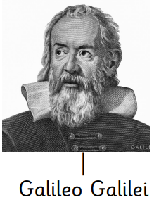
English

Shared Reading – Our Shared Reading book this half term will be Shakespeare’s A Midsummer
Night’s Dream. The comedy play is set in
Athens, and consists of several
subplots that revolve around the
marriage of Theseus and Hippolyta.

Writing – This term, we will be learning to write a formal letter of application, write a narrative focusing on dialogue and revisit writing third person stories set in another culture.

The children will explore these different forms of writing, looking at their features and usual grammatical aspects. We will practise writing different subordinate clauses in our writing, using our colourful Rainbow Grammar approach to grammar.

Spellings – We will continue to follow the Sounds and Syllables scheme of work for spellings. Please see the separate sheet for the spelling units for Spring 1. This will also be available on Class Dojo.
Year 5 Spring 1
Curriculum Overview
Maths
This half term, we will be beginning to answer multiplication and division questions. We will be looking into multiplication by 2 digit numbers and will secure knowledge of the column method to complete this. Then we will be looking at multiplying fractions.

Times Tables – Children are expected
to know their timetables to 12 x 12.

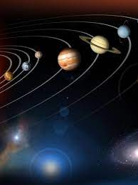



Understanding the Arts

Music – The children will be working on the 5-finger position on an electric keyboard and be able to play melodic patterns.

Art – We will be looking at Textiles and Collages and exploring materials, texture and natural objects, looking at techniques like loom making and raffia work.

v

Science - We will be looking at Space. We will identify the planets in our solar system and looking at their characteristics. We will have the experience of looking at the stars in the ‘Wonderdome’. We will also be learning about the Italian astronomer and physicist Galileo Galilei
PE - We will be developing our skills and techniques in swimming as well as tennis.
PSHE – Our PSHE unit focus for Spring 1 is on ‘Dreams and Goals’. We will look at being ambitious and planning for the future.
Computing & E-Safety - For Computing, we will continue looking at creating media in the form of video editing. We will be creating our own Online Safety videos.

We will continue to learn how to stay safe online with a focus on Online Bullying.



History - During Spring 1, we will be continuing our study Greek life and their achievements. We will then look more deeply at their way of life and at pivotal battles and the creation of the Olympic games.

RE - We will be answering the question, ‘If God is everywhere, why go to a place of worship?’ We will be working respectfully to answer this question and work together to discover why many people choose to visit places of worship.

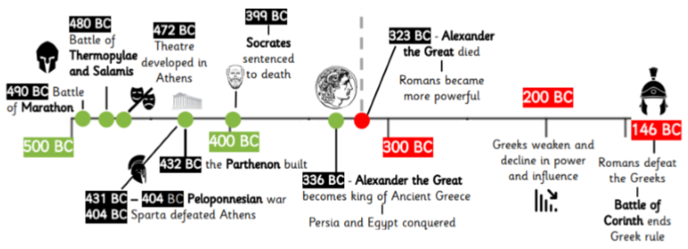
French – This term, we will be learning to say, write and read different elements of the weather as well as recapping our previous learning.
Geography – During the second half of this term, we will begin look at 4 and 6 figure grid references. We will also be recapping longitude and latitude from autumn term.

