Maths
We will be focusing on our Times Tables Knowledge and building on the skills from year 3. We will be using our place value knowledge to help us work out a variety of addition and subtraction as well as multiplication and division problems using the mastery maths approach. We will also be looking at perimeter in Measurement.

Times Tables – Children are expected to know their timetables up to 12 x 12. We will be practicing daily in preparation for our Multiplication Times Table Check in May 2024.

English
Class Reading – The Boy at the Back of the Class, The Girl Who Stole an Elephant

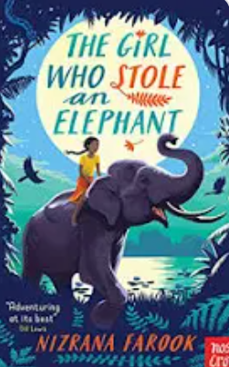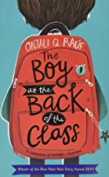
Writing – This term, we will be writing:
- Stories from other cultures.
- Persuasive writing
- Explanatory texts
We will be incorporating grammar into these lessons to ensure children are familiar with grammatical terms and vocabulary.
Spellings – We will continue to follow the Sounds and Syllables scheme of work for spellings. Please see the separate sheet for the spelling units in Spring. This will also be available on Class Dojo.

Year 4 Spring 1 Term
Curriculum Overview

Geography – Longitude and Latitude

We will looking at lines of latitude and longitude and how these help us in our understanding of various zones of our Earth.

PSHE - Pupils will give examples of people or things that might influence someone to take risks (e.g. friends, peers, media, celebrities), but that people have choices about whether they take risks. Pupils will be able to say a few of the risks of smoking or drinking alcohol on a person’s body and give reasons for why most people choose not to smoke, or drink too much alcohol.
Understanding the Arts
Music – We will be learning to play the Glockenspiel
- Block C - Tuned focus: Musical notation 2
- Block C - Revisit the staff
Art – We will be learning at printmaking skills and textiles. We will be able to create printing to represent Kente designs. Use tie dye to create colour designs. Combine media to create texture.

PE - We will be developing our skills and techniques in striking and fielding games and developing skills in gymnastics. Pupils will learn how to evaluate and recognise their own success.
Computing & E-Safety - For computing, we will be learning about online bullying and photo-editing. Pupils will use a text-based programming language to explore count-controlled loops when drawing shapes.
French – Pupils will learn and use the French for ‘I am, I have and I live, name the six periods of ancient Britain introduced in chronological order, be able to say the three types of people who live in Ancient Britain, tell somebody in French the three key hunting tools used, name the three types of dwelling used.

Science BIOLOGY
Animals including humans
Teeth and eating, digestion and food chains.

- What types of teeth do humans have?
- How do our mouth and teeth help with digestion?
- Can teeth tell us what animals eat?
- What are the parts of the digestive system?
- How does the digestive system work?
- What are food chains?
- How do I construct a food chain?
- How are teeth, food chains and digestion connected?
RE – Our RE focus this term is multi-faith. Our key enquiry question is, ‘Why do some people think that life is a journey and what significant experiences mark this? Year 4 World Religion Day focus is Buddhism.

