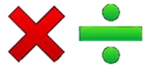
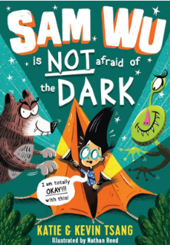
Maths
.
Multiplication and Division – We will begin our learning by focusing on sharing equally, grouping and exploring arrays. We will then move onto using the formal written methods to solve two digit by 1digit problems.

Times Tables– This half term, we will be securing our knowledge of the three times tables. We will be exploring multiplication facts for the 3, 4, 6 and 8 times tables.

Geography
Our Geography unit will be centred around UK Studies. The children will learn to name and locate counties and cities of the United Kingdom, explore geographical regions and their identifying human and physical characteristics. We will explore key topographical features (including hills,
mountains, coasts and rivers)

English
Reading – In our Reading lessons
during Spring 1, we will be
reading ‘Sam Wu is not afraid of the
dark’. We will be exploring
the author’s intentions and how an atmosphere is created. We will be exploring themes throughout the text.

Grammar – Our grammar work for this half term will focus on subordinating and coordinating conjunctions and inverted commas.

Writing
In Writing, we will be writing a letter to complain based on a real-life scenario. We will then write a dialogue through historical narrative using our knowledge of the Bronze and Iron Age,

Year 3 Spring 1
Curriculum Overview

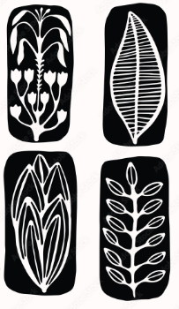
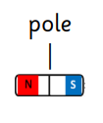
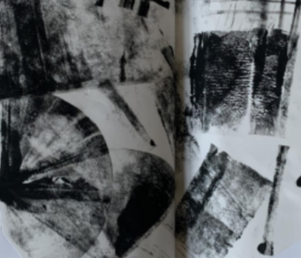
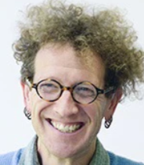
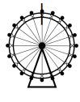
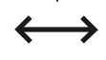


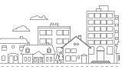

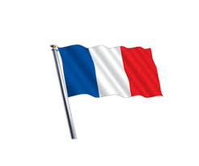

Understanding the Arts
Art:
In Art we will be exploring
the artist Neil Bousfield who
is a famous printmaker. We
will be creating our own block printing slab and print a repeated pattern.

Music:
During our Music lessons, we will be mastering rhythm as well as recognising beats in a bar (time signatures/metre).

PE – During this half term, for our indoor PE we will be learning symmetrical and asymmetrical balances. Our outdoor PE sessions will be looking at batting. skills,
RE- In R.E. we will be focusing our learning
on Islam. We will be exploring and
developing an understanding of who is
Muslim, what they believe in and where
they go to worship.

PSHE – We will be spending the half term exploring dreams and goals. This will foster resilience, respect and aspiration. We will encourage the children to look for challenges and discuss how to overcome them.

Science –
In our science lessons, we will be learning about forces and magnets. We will investigate contact and non-contact forces through experiments. We will measure forces using a Newton Metre, We will explore the effects of frictions as an object travels on different surfaces. We will explore magnetism through experiments of objects which are magnetic and non-magnetic.

French – We will be learning how to say different instruments accurately in French,
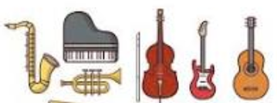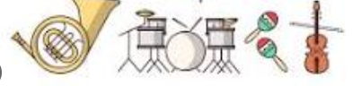

Computing – This half term, we will focus our Online Safety learning on ‘Online Relationships’. Our computing learning will focus on capturing and editing digital still images to produce a stop-frame animation that tells a story.

