Geography
Our first Geography unit will look at the similarities and differences between the Lake District, Poland and Jamaica. The children will look at the various landscapes of these three countries with a particular focus on their mountain ranges and how they were formed.

English
Reading –

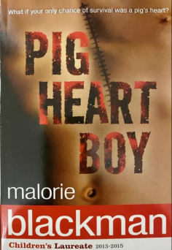
During our reading lessons, we will be reading ‘Pig Heart Boy’ The story centres on Cameron, a thirteen-year-old boy, who is in need of a heart transplant. As time appears to be running out for him, he agrees to take part in a pioneering transplant procedure, using a pig’s heart instead of a human one.
Writing
In writing, we will be writing a story with a moral based on the story. ‘The boy who cried wolf’. We then will go onto writing an explanatory text to explain how something works.

Maths
Four operations: Children will deepen their understanding of the columnar method for multiplication of 4-digit numbers by 1- and 2-digit numbers and develop an understanding of written methods for division. After this, children learn about the order of operations, investigating its effect on calculations and considering why it is important to have an agreed order.
Fractions: Children will continue from their knowledge in Year 5 to understand how to simplify and order fractions, moving on to the subtracting, adding and multiplying them.

Year 6 Autumn 2
Curriculum Overview

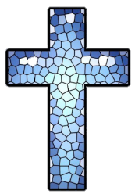
RE-In R.E. we will be focusing our learning
on answering the question:

Why do some people believe god exists?

Design & Technology
Pupils will study and make street foods from different cultures. The aim of these sessions is to encourage pupils to think about their own diet and snacks and how their nutritional value could be improved. The block provides an opportunity for pupils to learn about a range of different cultures.
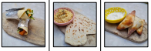
Music– During the half term, we will be learning how

- Science – Our topic is Light. The children will recognise that light appears to travel in straight lines. The children will be taught to use the idea that light travels in straight lines to explain that objects are seen because they give out or reflect light into the eye. The children will use the knowledge to know that light travels in straight lines to explain why shadows have the same shape as the objects that cast them.

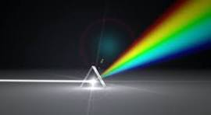

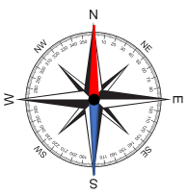
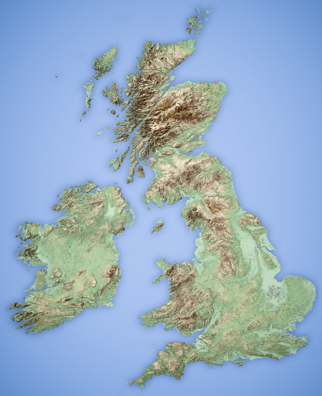
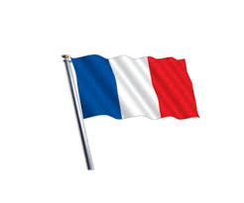
Computing – In our computing lessons this half term, we will continue to Pupils will recognise how the WWW can be used to communicate and be searched to find information.
Music – The children will continue to learn how to alter tempo and rhythm to create effects. They will also be learning the keyboard.

PSHE – Over this half term, we will be spending time focusing on our school values and the British Values. We will be addressing bullying and prejudiced behaviour. The will learn the difference between an active and passive bystander.

French – Pupils will be able to count to 20, say their name and age, say hello and goodbye and then ask and answer about how they are feeling, and say where they are.

PE – During this half term, we will be developing our
Dance skills in our carnival unit. Children will also be learning the skills and invasion games of Tag Rugby.

