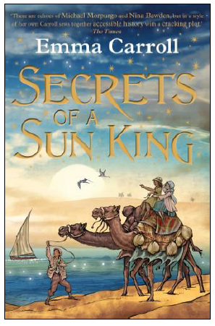
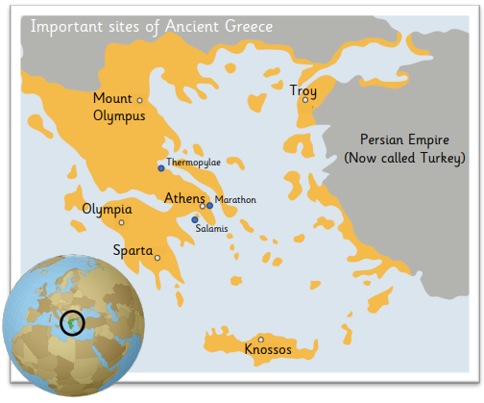
Maths
This half term, we will be completing a unit of work on Fractions. They will be learning about equivalent fractions, improper fractions and mixed numbers. They will also be learning how to add and subtract fractions.

Times Tables – Children are expected to know their timetables to 12 x 12.
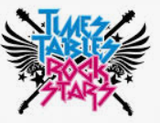

Year 5 Autumn 2
Curriculum Overview
English

Shared Reading – Our Shared
Reading book this half term will
be Secrets of a Sun King by Emma
Carroll. Set in 1922, the story tells
of Howard Carter’s search for the
tomb of Tutankhamun and the
adventures of the main character,
Lil.

Writing –

We will be writing dialogue within a narrative. This will be written in the first person and relate to our work on the Greeks, looking at their myths and legends. Children will be focusing on punctuation speech correctly and wiring using expanded noun phrases.

Spellings –
We will continue to follow the Sounds and Syllables scheme of work for spellings. Please see the separate sheet for the spelling units for Autumn 2. This will also be available on Class Dojo.

Understanding the Arts
Music – The children will be working with the brilliant music specialist Mrs Leech, looking song structures-learning how to sing in unison and harmony. They will they add tuned percussion to play the melody line.
Children will also continue to learn how to play the Ukulele.

DT – Pupils will look to Middle Eastern and Danish foods for inspiration and consider what they can learn from the diets of different cultures. They will learn how to make flatbreads and use a range of techniques to make delicious, appetising food.

v

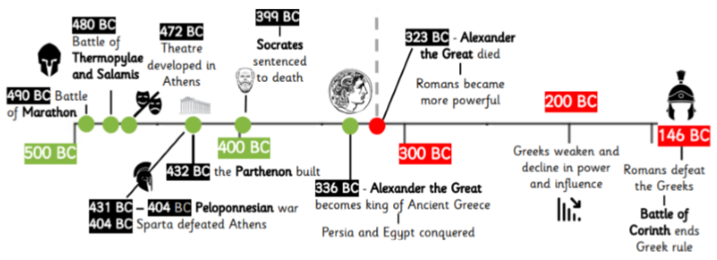
French-Vegetables (Les Legumes)
Pupils will be able name and recognise up to 10 vegetables, attempt to spell some of these nouns using the correct article, learn simple vocabulary.
RE - What would Jesus do? (Can we live by his values in the 21st Century?)
Pupils will outline Jesus’ teaching on how his followers should live and offer interpretations of two of Jesus’ parables and say what they might teach Christians about how to live. They will explain the impact Jesus’ example and teachings might have on Christians today. Pupils will express their own understanding of what Jesus would do in relation to a moral dilemma from the world today.

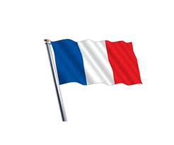

PSHE – Valuing Difference
Pupils will give examples of different faiths and cultures and positive things about having these differences. They will explain how people sometimes aim to create an impression of themselves in what they post online that is not real and what might make them do this.
Computing & E-Safety - For computing, we will be learning about Vector drawings. This will involve creating images in a drawing program by using layers and groups of objects. We will continue to learn how to stay safe online with a focus on Online Relationships and Online Reputation.
PE - We will be developing our skills and techniques in swimming as well as Multi-skills and Netball.
History

During Autumn 2, we will study Greek life and their achievements and their influence on the western world. We will look closely at who they were, when they ruled and what beliefs they held. We will then look more deeply at their way of life and at pivotal battles and the creation of the Olympic games.

Science – This half term, we will be looking at Materials and their Properties. Children will explore physical and chemical changes. They will also learn about the structure of materials, conductors and insulators and testing solubility of different substances.

