Maths
We will be focusing on our Place Value Knowledge and building on the skills from year 3.
Number – Addition & Subtraction
Measurement – Area
Number – Multiplication & Division

Times Tables – Children are expected to know their timetables up to 12 x 12. We will be practicing daily in preparation for our Multiplication Times Table Check in May 2024.

English

Whole Class Reading –
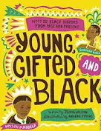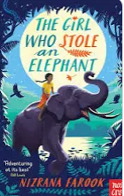
Writing
During this half-term we will be writing a newspaper report as well as a diary entry. We will look at how we use capital letters, inverted commas for dialogue and how to punctuate fronted adverbials.
Spellings – We will continue to follow the Sounds and Syllables scheme of work for spellings. Please see the separate sheet for the spelling units for autumn. This will also be available on Class Dojo.

Year 4 Autumn 2 Term
Curriculum Overview
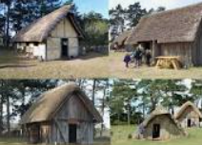



Understanding the Arts
Music – This half-term the children will be focussing on singing introducing the notion of texture. They will progress to singing parts in an ensemble.
DT – In DT, we will explore the difference between freshly made food and mass-produced food. We will be making pizza, bread rolls and soup.


Computing & E-Safety –
For computing, we will be learning about how to stay safe online with a focus on Online Relationships Online Reputation Children will learn how to capture and edit audio to produce a podcast, ensuring that copyright is considered.
.
French – Pupils will be able to name and recognise up to 10 vegetables, attempt to spell some of these nouns using the correct article, learn simple vocab to facilitate role play about buying vegetables from a market stall, say the quantity they would like a vegetable.
Science - CHEMISTRY
States of Matter
- What are solids, liquids and gases?
- What is matter and what does the word ‘state’ mean?
- Melting: how do materials change state?
- Evaporating: how do materials change state?
- Condensing: how do materials change state?
- Summary: how do materials change their state of matter?
RE
Our RE focus this term is Christianity. The children will answer the question: Why is Jesus inspiring to some people today?

History:
Britain’s settlement by Anglo-Saxons and Scots

- Why did the Anglo-Saxons come to Britain?
- Where did the Anglo-Saxons come from?
- What was life like for Anglo-Saxons in Britain?
- What Kingdoms were formed by the Anglo-Saxons?
- How do we know about the Anglo-Saxons?
- How did religion influence the Anglo-Saxons and how do we know this?

PE - We will be developing our skills and techniques in dance with a space theme. The children will continue to work on invasion games.
PSHE – Our PSHE unit focussing upon valuing differences and challenging stereotypes.
.

