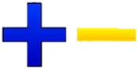
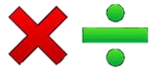
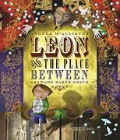
English
Reading – In our Reading lessons
during Autumn 2, we will be
reading ‘Leon and the Place
Between’ and ‘Twas the Night Before
Christmas’. We will be exploring
the author’s intentions and how an atmosphere is created.

Grammar – Our grammar work for this half term will focus on coordinating conjunctions, expanded noun phrases and adverbs.

Writing
In Writing, we will be using our knowledge of rocks to help us write a non-chronological report on the different types of rocks. After this, we will then use our grammar knowledge to help use write a first person narrative focussing on expanded noun phrases and fronted adverbials.

Maths
Addition and Subtraction – We will be learning the formal written method (the column method) to help solve addition and subtraction problems.

Multiplication and Division – We will be our learning, focussing on ‘lots of’ for multiplication and equal groups of for division. We will then move onto using the formal written to solve two digit by 1digit problems.

Times Tables– This half term, we will be securing our knowledge of the three times tables.

History
During Autumn 2, our History unit is based on ‘Changes to Britain from the Stone Age to the Iron Age’. We will be developing a curiosity about the past and how people used to live during this period of time. We will be learning about chronological order, how artefacts, burials, monuments and places teach us about the past as well as learning about changes to technology and how people used to live.

Year 3 Autumn 2
Curriculum Overview

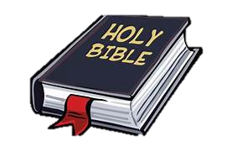
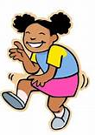
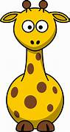
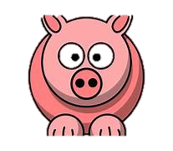
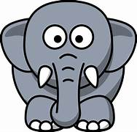
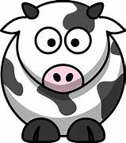
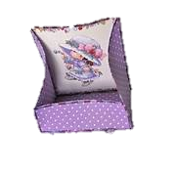
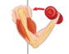
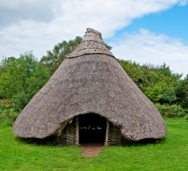
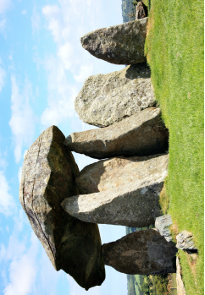
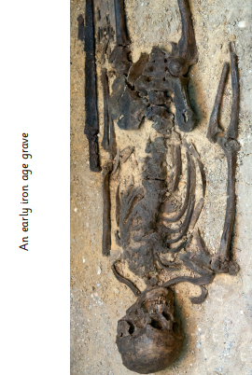
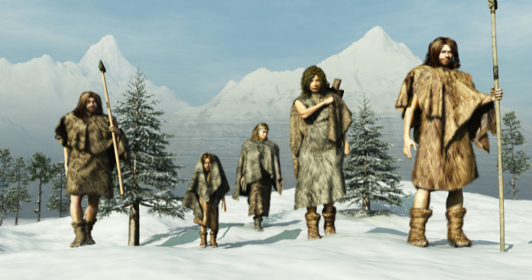
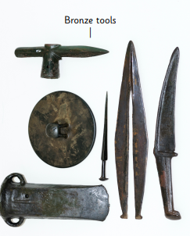
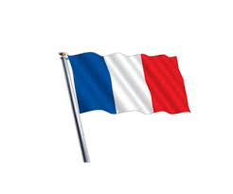
PSHE – We will be spending the half term exploring different community groups and why it is important to have them. We will be talking about respect and tolerance and how they can help create a happier, safer classroom.

Understanding the Arts
Design and Technology – We will explore ways to stiffen fabrics. We will have opportunities to cover a box with
cloth and then go on to create a
rigid box out of fabric.

Music:
During our Music lessons, we will be mastering rhythm as well as recognising beats in a bar (time signatures/metre).

Science – Our topic is Animals including humans. We will be learning about the different food groups and how food can affect the body. We will be learning about the human skeleton and naming different bones within the skeleton. After that, we will focus our learning on the muscles. We will be
exploring where the muscles
are in the body and what
they do.

RE-In R.E. we will be making connections between stories in the Bible and what Christians believe about creation. We will look at why Christians
use the Bible and how they use it to
guide their lives.

PE – During this half term, we will be our
knowledge of shape to help use create different
shapes using our bodies.

French – We will be learning how to say different animals in French as well as learning how to spell them accurately.

Computing – This half term, we will focus our Online Safety learning on ‘Online Relationships’. Our computing learning will focus on capturing and editing digital still images to produce a stop-frame animation that tells a story.

