English

Class Reading – Rooftoppers and Skellig

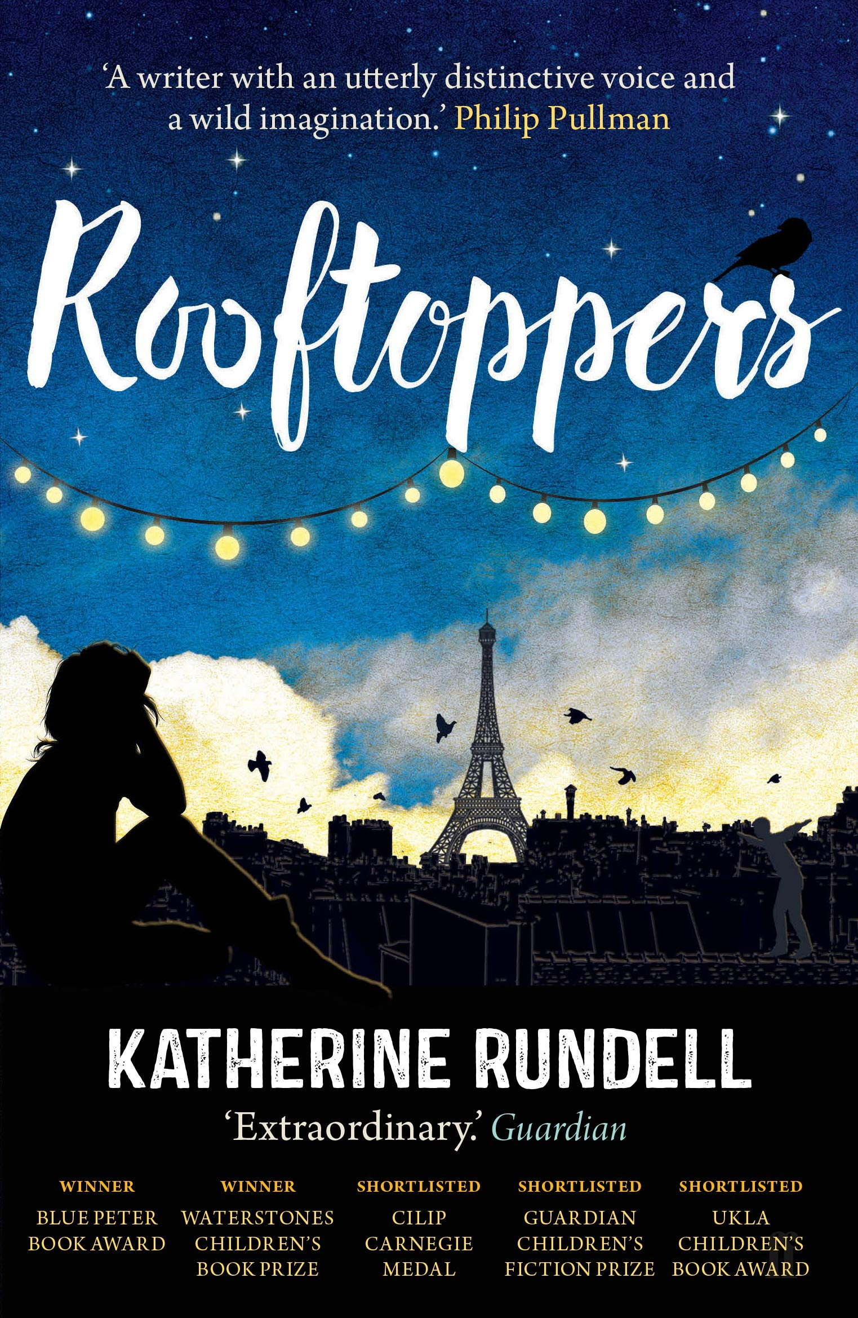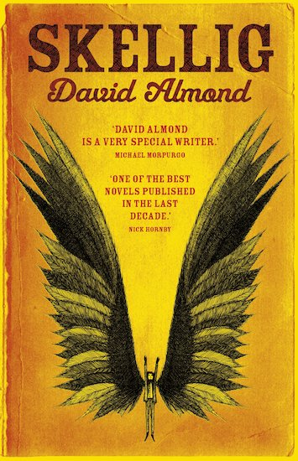

Writing – This term we will be learning about the features of an autobiography and writing our own.
Spellings – We will continue to follow the Sounds and Syllables scheme of work for spellings. Please see the separate sheet for the spelling units for Autumn 1. This will also be available on Class Dojo.

Maths
Number – Number & Place Value
Number – Addition & Subtraction

Times Tables – Children are expected to know their timetables to 12 x 12.

Year 6 Autumn 1
Curriculum Overview

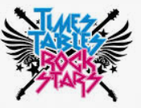

Understanding the Arts
Music – The children will be working with Hot House, where they will be given the opportunity to learn to play the keyboard and work collaboratively to create a class performance.



Art – We will be refining and modifying our drawing skills to draw in detail and use scale and proportion producing drawings from different perspectives.

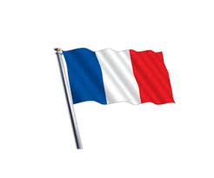
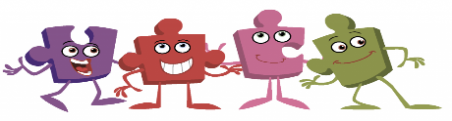
The children can access MYON which has a multitude of educational books. Your child’s teacher will provide logins for each child.

French – This term pupils will be completing the unit presenting myself where they will learn to count to 20, say their name and age, say hello and good-bye and ask and answer how they are feeling.
RE – Our RE focus this term is to answer our key enquiry question, ‘What do religions say to us when life gets hard?’

History – The Battle of Britain
We will start our history by looking at the cause of World War Two and why Britain declared war on Germany in 1939. We then look at why rationing was introduced and the impact of food shortages on the country. Next, we will look at why people were evacuated from cities. From this, we will find out what happened during the Battle of Britain and the Blitz.

PE - We will be developing our skills and techniques in Communication and Tactics and multi-skills. Class teachers will keep children updated on PE days.
PSHE – Our PSHE unit focus for
Autumn 1 is: Being Me in the World’’.

Computing & E-Safety - For computing, we will be learning about Computing Systems and Networks where we will look at internet communication. We will continue to learn how to stay safe online with a focus on safe-image and identity.
Science - Living things and their habitats
We will start the unit by learning about the scientist Carl Linnaeus and how he created the taxonomy system to organise living things. We learn at how we classify vertebrates within the animal kingdom and look at the similarities and differences between them. We go on to learn about the many different types of invertebrates and classify the ones we know and don’t know.


