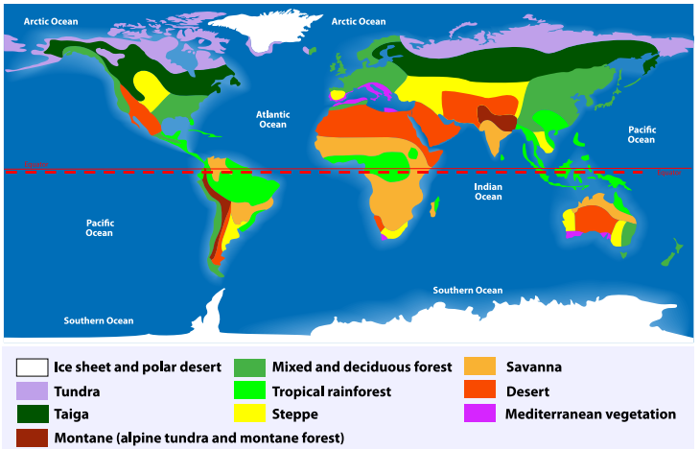
English

Shared Reading – This half term, our Shared Reading lessons will be focused around the brilliant book Shackleton’s Journey which tells of Ernest Shackleton’s incredible expedition as he attempted to cross Antarctica.

Alongside this wonderful book,
the children will be exposed to
a variety of text types which
are designed to enrich their
vocabulary and broaden their
understanding of the world
around them.

Writing – This half term we will be learning about and composing our own stories set in another culture, writing a balanced argument.
Spellings – We will continue to follow the Sounds and Syllables scheme of work for spellings. Please see the separate sheet for the spelling units for Autumn 1. This will also be available on Class Dojo.

Maths
This half term, we will be covering Place Value up to 1,000,000, moving onto Addition and Subtraction containing of numbers with more than four digits and looking at line graphs and two-way tables in our unit on Statistics.

Times Tables – Children are
expected to know their
timetables to 12 x 12.

Year 5 Autumn 1
Curriculum Overview

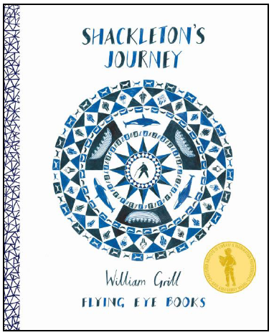

Understanding the Arts
Art – We will be learning about the German-British artist, Frank Auerbach and Austrian painter and architect, Friedensreich Hundertwasser. The children will be creating abstract paintings and have a go at subtractive drawing.

PE - We will be developing our skills and techniques in swimming, multi-skills and invasion games this term.

Geography
During the first half term, children will be discovering about the world, including its continents, countries and major cities. We will focus on North America, South America and Europe. We will use maps and atlases, locate the key physical and human characteristics of a destination, taking note of the biomes across the world.

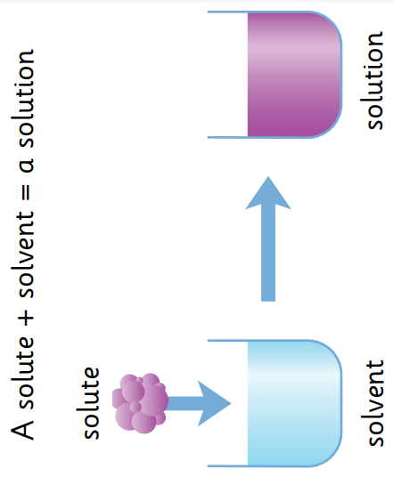
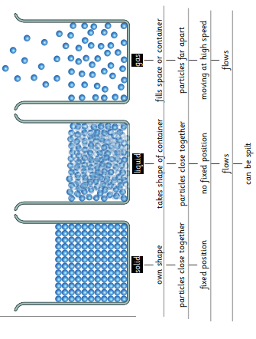

Science – In our Science for Autumn 1, we will look at animals including humans. In Autumn 2 we will introduce Properties and changes of materials. We will look at reversible and irreversible changes and demonstrate that dissolving, mixing and changes of state are reversible changes.
RE - We will be learning about
Christianity. Our key enquiry
question is, ‘Why do some people
believe God exists?’

French – This term, pupils will develop their phonetical understanding of the French language and will be looking at the French names for a variety of vegetables.
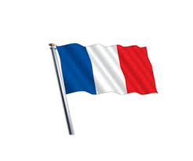

PSHE – Our PSHE unit focus for
Autumn 1 is ‘Me and my relationships.’

Computing & E-Safety - For computing, we will be completing a unit on E-safety. This will involve focusing on supporting children and teaching them how to stay safe online with a focus on what information and details should be shared online and online bullying.

