Maths
We will be focusing on our Place Value Knowledge and building on the skills from year 3. We will be using our place value knowledge to help us work out a variety of addition and subtraction problems using the mastery maths approach.

Times Tables – Children are expected to know their timetables up to 12 x 12. We will be practicing daily in preparation for our Multiplication Times Table Check in May 2024.

English

Class Reading – The Queen’s Nose and The Girl Who Stole an Elephant

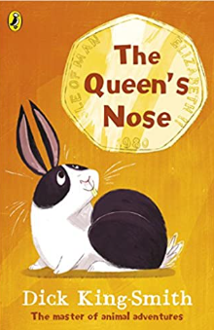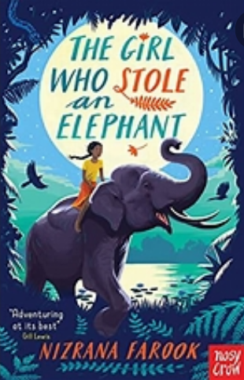
Writing – This term we will start by looking at poetry. We will create our own Haiku poems based on weather.
Then we will start with writing narrative based on The Journey. We will look at how we use capital letters, inverted commas for dialogue and how to punctuate fronted adverbials.
Spellings – We will continue to follow the Sounds and Syllables scheme of work for spellings. Please see the separate sheet for the spelling units for Autumn. This will also be available on Class Dojo.

Year 4 Autumn Term
Curriculum Overview
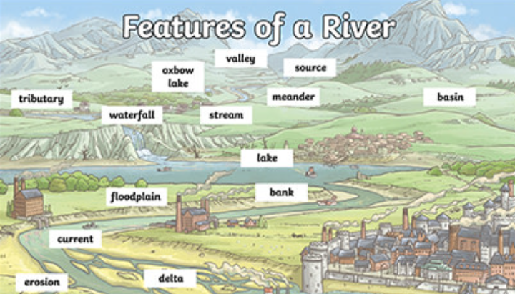


Understanding the Arts
Music – The children will be involved in learning how to read music
Art – We will be learning Painting techniwues including overpainting (wet-on-wet), making tertiary colours and responding to the work of artists.
DT – In DT, we will look at Food and Nutrition, and what our food contains.

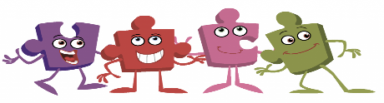
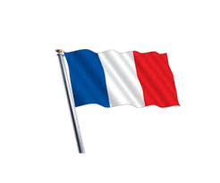
PE - We will be developing our skills and techniques in invasion games and teamwork.
Geography – Rivers and The Water Cycle

We will look at physical geography – including: climate zones, biomes and vegetation belts, rivers, mountains, volcanoes and earthquakes, and the water cycle. We will also look at human geography including: types of settlement and land use, economic activity including trade links and the distribution of natural resources including energy, food, minerals and water.

PSHE – Our PSHE unit focus for
Autumn 1 is ‘Being Me in the World’.

Computing & E-Safety - For computing, we will be learning about how to stay safe online with a focus on Self-Image and Identity. We will also be learning basic learning skills.
Science - Living things and their habitats
We will be learning how living things can be grouped in a variety of ways using classification keys. We will also be looking at how environments can change and that this can sometimes pose dangers to living things.
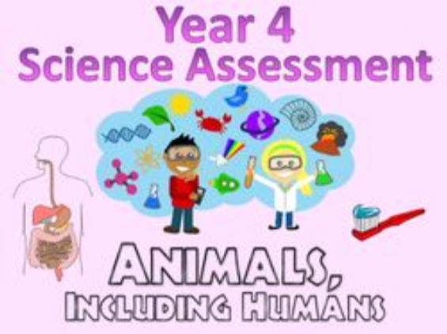

RE – Our RE focus this term is Christianity. Our key enquiry question is, ‘Why is Jesus inspiring to some people?’

French – This term pupils will be learning how to read and write the date, including days of the weeks and months of the year.

