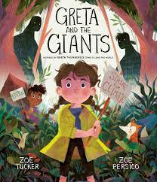
English
Reading – During our reading lessons,
we will be reading ‘Greta and the giants’
and ‘Pebble in my pocket’. We will using
our prediction skills to predict what will
happen next in the story as well as using our inference skills to read between the lines to help us explain the author’s intentions.

Grammar – During this half term, we will be securing our knowledge of capital letters, full stops and commas in a list. We will be recapping nouns, verbs and adjectives. Our new grammar learning will focus on subject, predicate and stop.

Writing
In writing, we will begin writing poems based on emotions using the book ‘The Colour Monster’. After this, we will be writing a set of instructions on ‘How to wash a woolly mammoth’, using imperative verbs and adverbs.

Geography
Our first Geography unit will focus on ‘Map and Fieldwork skills’. We will be learning about the eight points on a compass (four are cardinal – N, E, S, W and four are intercardinal NE, NW, SE, SW). We will use these compass points to identify human and physical features on a map of our local area. Using Digimaps, we will use our locational knowledge to compare and contrast different locations.

Maths
Place value – We will be learning to identify the value of each digit in a given number. We will also begin to order and compare numbers within 1000.

Addition and Subtraction – We will be learning how to use mental and written methods to add and subtract two and three digit numbers.

Times Tables and TT Rock Stars – This half term, we will be recapping our 2, 5 and 10 times tables as well as learning our 3 times tables.

Year 3 Autumn 1
Curriculum Overview

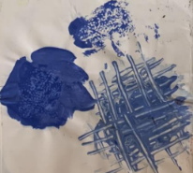
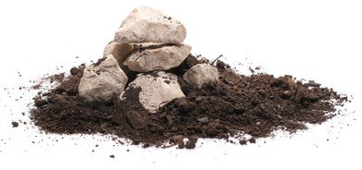
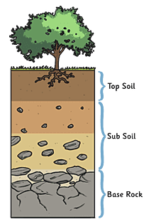
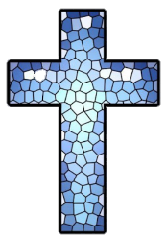
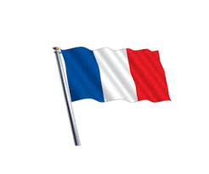
RE-In R.E. we will be focusing our learning
on Christianity. We will be exploring and
developing an understanding of who is
Christian, what they believe and where
they go to worship.

Understanding the Arts
Art – In our Art block of learning, we will experiment with using different materials such as paint to create different marks.
We will also learn about mixing
colours and using different
painting techniques such as tonking and sgraffito.

Music– During the half term, we will be learning how to play a new musical instrument, the hand bells.

PE – During this half term, we will be developing our throwing and catching skills, how to use space and how to travel in different directions.

French – We will begin our French learning by locating France on a map and identifying where French is spoken in other countries. Also, we will be learning how to greet each other and how to say the numbers 0-10 in French.

Science – Our topic is Rocks and Soils. We will be learning about the three different types of rocks (sedimentary, igneous and metamorphic rocks) and their appearance. As part
of this unit, we will be taking
a closer look at soil and
describing the different layers.

Computing – In our computing lessons this half term, we will be learning how to log onto the internet to take an Accelerated Reader quiz. We will also be learning about the importance of using an avatar in our ESafety lessons.

PSHE – Over this half term, we will be spending time focusing on our school values. We will also be looking at ‘Being Me’ through our SCARF scheme of work, where children will learn about rights and responsibilities.



