

Religious Education
Year 6
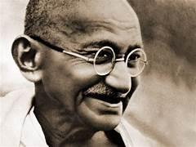
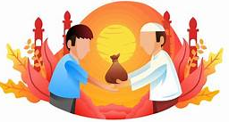

What difference does it make to believe in Ashima, Grace and Ummah?
Gandhi

Zakat

God’s Grace

Key Content
- Hindus believe in Ashima. This means they believe in no violence, eating no meat and wearing no leather.
- Hindus try and live life without killing or harming anything that lives.
- Gandhi practiced Ashima in the liberation of India
- Christians believe in the idea of grace from God. This means that God loves people unconditionally and is willing to offer forgiveness to anyone for anything.
- Chrisitians are committed to believing God’s grace and they think God forgives those who truly repent.
- The worldwide Muslim community is called the Ummah.
- For Muslims being part of the Ummah is very important and they stick together under one God, Allah,
- Muslims express Ummah through the third and fifth pillars of Islam Zakat and Hajj. Hajj is the pilgrimage to Makkah and Zakat is the charitable donation.
- Prophet Muhammad (PBUH) is an important role model to Muslims because he shows Muslims how best to live and he created one multiracial community of Muslims, spreading Allah’s words.
Key Vocabulary
- Ashima – harmlessness
- Ummah – community
- Grace – the generosity of God

