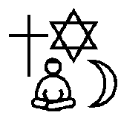
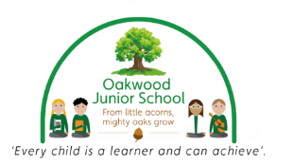
Religious Education
Year 5
Is it better to express your belief in arts and architecture or in charity and generosity?
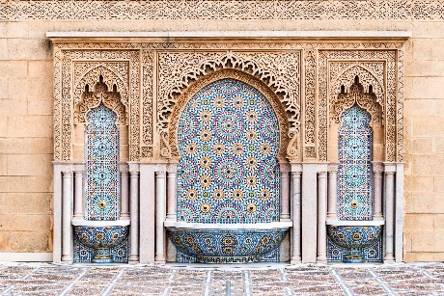

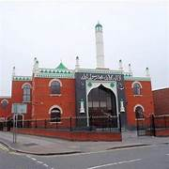

Derby Jamia Mosque

Islamic architecture

Charity

Key Content
- A Muslims sacred place and place of worship is a Mosque.
- In Islam, there are no images of Allah or Prophet Muhammad (PBUH) because they mislead rather than enlighten. It is strictly forbidden to depict Allah or Prophet Muhammad (PBUH) in pictures.
- Instead, Muslims use geometric and natural patterns to create beauty.
- The Five Pillars of Islam are an important part of Muslim life. Muslims believe they must do these five things in order to live a good and responsible life.
- In the Islamic religion, Muslims obey the pillar of Zakat. Zakat is the compulsory giving of a set proportion of one’s wealth to charity,
- Muslim Aid is an international charity that provides relief and development assistance to people in need regardless of race, religion or gender.
- Christians believe sharing and kindness are an important part of their religion.
- Volunteering, helping and honesty are part of Christianity.
- Christians use art and architecture to worship and remember Jesus.
- Christian Aid is a charity supported by most Christian churches in the UK. It works for disaster relief and supports development projects mainly in developing countries.
Key Vocabulary
Architecture – the art or practice of designing and constructing buildings
Charity – the voluntary giving of help, typically in the form of money or food
Enlighten – to give spiritual knowledge
Generosity – the quality of being kind and generous
Poverty – not having enough money for basic needs such as food, clothing or shelter
Ummah – the worldwide community of Muslims
Zakat – paying a charity tax to benefit the poor and the needy

