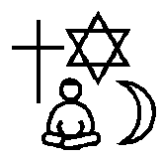

Religious Education
Year 4
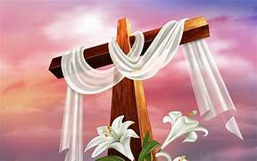
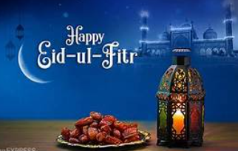
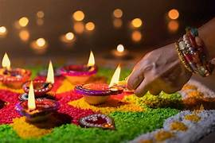
Why are festivals important to religious communities?
Easter

Diwali

Eid ul Fitr

Key Content
- In Holy Week, Christians try to remember what happened to Jesus.
- The common services that Christians attend during Holy week are Palm Sunday, Maundy Thursday, Good Friday and Easter Sunday.
- Palm Sunday is the first day of Holy week and it celebrates Jesus’ arrival in Jerusalem on a donkey.
- Maundy Thursday is when Christians remember when Jesus ate the Passover meal with his Disciples, breaking bread and drinking wine.
- The Last Supper was the last meal Jesus had with his disciples. Many Christians remember this in church through a service called Holy Communion, Eucharist or Mass. It is a reminder that Jesus sacrificed his life for mankind.
- Good Friday commemorates the execution of Jesus by crucifixion. It is a day of mourning in church.
- Easter Sunday marks Jesus’ resurrection.
- During the month of Ramadan, Muslims will not eat or drink during daylight hours. This is called fasting. Ramadan remembers the month the Qur’an was first revealed to Prophet Muhammad.
- Eid ul Fitr is a celebration that takes place at the end of Ramadan.
- Diwali is the festival of light and is celebrated by Hindus between October and November.
- Diwali celebrates the story of Rama and Sita.
- The story of Rama and Sita symbolises good overcoming evil.
Key Vocabulary
Ramadan – It is the ninth month of the Muslim year, where strict fasting is observed.
Resurrection – is the belief that Jesus came back to life three days after his death.
Disciple – A person who lives by God’s word
Blessing – A way to wish someone good luck
Prosperity – the state of being wealthy and successful
Passover – a celebration of the story of Exodus

