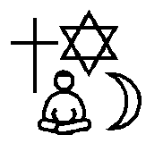

Religious Education
Year 3
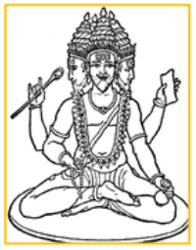
What do different people believe about God?
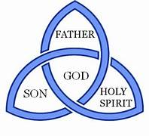
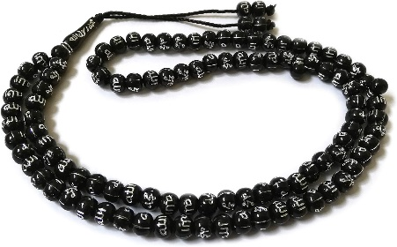

The Holy Trinity

Islamic Muslim Prayer Beads

The Trimurti
tar and Cresecent

Key Content
- There are different ideas about God: God as love; God as father; God as light; God as creator.
- Christians think of God as the Trinity – Father, Son and Holy Spirit. Three people in one.
- Christians believe God answers people’s prayers.
- Moses is a prophet for Muslims, Jews and Christians.
- Muslims believe in one God, Allah.
- Muslims use 99 Beautiful Names of Allah. Some of these names are: The Most Merciful; The First; The Loving One; The Protecting Friend; The Forgiver.
- The Qur’an is a guide to help
Key Vocabulary
Faith: belief.
Bible: Christian Holy Book.
The Qur’an: Muslim Holy Book.
Trinity: Christian belief that God is made up of three persons.
Shahadah: Islamic declaration of faith.
Prophet: A teacher/messenger of God.
Saint: A person who is believed to be extremely holy and close to God.
Mandir: Hindu place of worship
Murti: a sacred statue of a god or goddess
The Vedas: a collection of hymns praising the Vedic Gods
Muslims live their lives.
- Hinduism is the world’s oldest
religion.
- Hindus believe in one supreme God
called Brahman and he is
represented in many forms.
- Hindus believe there are three great
Gods called the Trimurti. These
Gods are called Vishnu, Shiva
and Brahma.
- Hindus believe God is present in all
livings things and all livings things
have a soul so they cannot be destroyed.

