Year 6 Literature Spine
Autumn 1 | Autumn 2 | Spring 1 | Spring 2 | Summer 1 | Summer 2
Rooftoppers  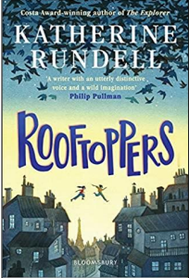  Contemporary narrative set in Victorian times written by acclaimed author Katherine Rundell  A beautiful adventure story narrating the quest to find the birth mother of feisty orphan Sophie  Themes: friendship, determination, love, ingenuity and those living on the fringes of society | Pig Heart Boy  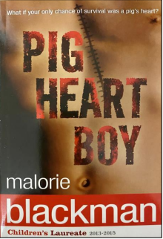  A second contemporary narrative by Malorie Blackham  The story of a boy whose only hope of survival is to have a transplant using a pig’s heart  Themes: animal rights, quest to extend life through science, illness, friendship, loyalty, family and determination | 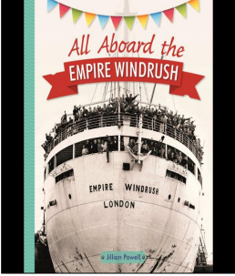  All aboard the Empire Windrush  Contemporary non-narrative to complement CUSP Windrush History Unit.  Told from the perspective of a young traveller.  Narrates the history of the Windrush generation and their contribution to British life  Themes: change, prejudice, national identity and social history | Skellig  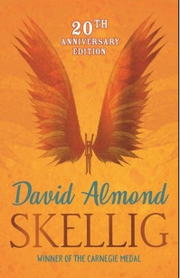  Contemporary narrative by acclaimed author David Almond  Narrates the story of two friends who find a strange creature who needs their help to survive.  Representation of an ill sibling  Themes: change, friendship, family, death, fear, adventure | An introduction to Dickens  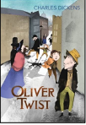  Including Oliver Twist  This unit is designed to give pupil’s an understanding of Dickens and the context of his work, including a grounding in understanding archaic language  Themes: life in Victorian times, social and historical contexts, impact on seminal authors on modern British culture | Dare to be you  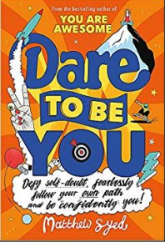  A non-narrative book of empowerment for young people preparing for transition to secondary school.  Exemplified through a vast range of role models, this book will help pupils celebrate difference, develop inner confidence and independence.  Themes: difference, inspiration and kindness
The Listeners  Walter de la Mare  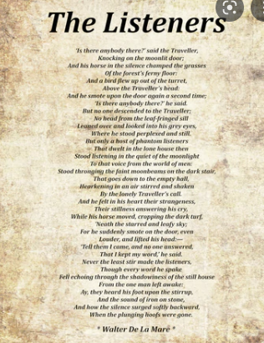  A heritage poem full of rich and archaic language.  This poem tells the story of an unnamed traveller exploring an abandoned house inhabited by ghosts.  Themes: supernatural, fantasy and mortality | How to Live Forever  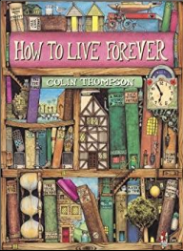  Contemporary narrative picture book, beautifully illustrated  Building on the study of Pig Heart Boy. The story explores the ethics and implications of immortality. | The Island  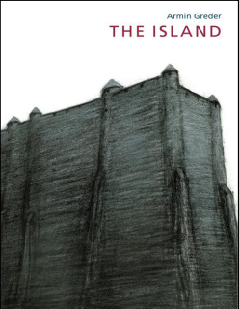  Contemporary narrative picture book  A powerful story of a man who washes up on the beach of an island  Narrative parallels to the themes addressed in the CUSP Windrush unit.  Themes: refugees, xenophobia, social politics and human rights

