Year 5 Literature Spine
Autumn 1 | Autumn 2 | Spring 1 | Spring 2 | Summer 1 | Summer 2
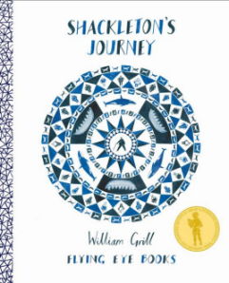  Shackleton’s Journey  Contemporary non-narrative picture book  Narrates the history of the Antarctic explorations of Shackleton and his crew | Secrets of a Sun King  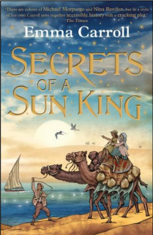  Contemporary historical narrative with both female author and protagonist  A glorious tale of mystery, intrigue and adventure with great historical references throughout  Draws on learning from Ancient Egypt and Tutankhamun  Themes: friendship, family, feminism and tenacity | A Midsummer Night’s Dream  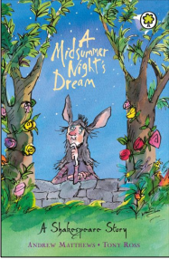  Heritage classic- an introduction to the work of Shakespeare  A magical and simple retelling of the classic story including some simple plot analysis and information about Shakespeare and the Globe Theatre. | The Boy in the Tower  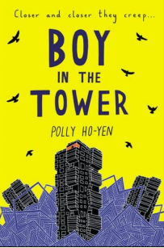  Contemporary science-fiction narrative telling story of monster plants consuming buildings in the city  Themes: mental health, young carers, friendship, trust, resilience and anxiety  Narrating some of the joys and challenges of living in an urban community  Moving, thought-provoking and challenging in equal measure | The Explorer  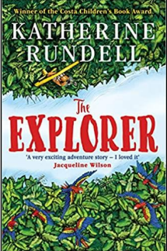  Contemporary narrative  An adventure story in which four children learn to survive in the Amazon Rainforest  Exploring the ethics behind human exploration and environmental responsibility  Themes: friendship, adventure and the natural world | Five Children and It  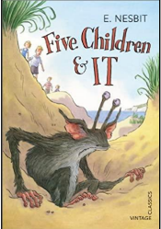  Heritage fantasy narrative by seminal author and poet E. Nesbit  Five children find a sand fairy who grants them wishes with humorous consequences  Full of rich, archaic and challenging language to explore  Historical references throughout with the opportunity to explore historical attitudes to gender, race and social discrimination
 | If  Rudyard Kipling  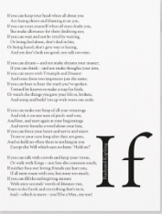  An inspirational heritage poem by a seminal British poet and author  A ‘guide for life’ which explores the idea of coming of age  Beautifully written and still relevant to modern living  Challenging and archaic language throughout  A depth study of the poem and the poet | 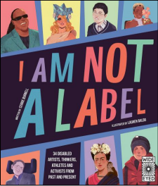  I am not a Label  A beautifully illustrated anthology celebrating the achievements of modern and historical role models who have overcome disability, mental health issues or wider life challenges  A book that challenges stereotypes and assumptions | Daffodils  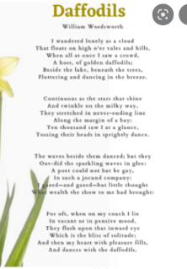  William Wordsworth  Heritage poem by seminal British poet  Challenging and archaic language throughout

