Year 4 Literature Spine
Autumn 1 | Autumn 2 | Spring 1 | Spring 2 | Summer 1 | Summer 2
The Queen’s Nose  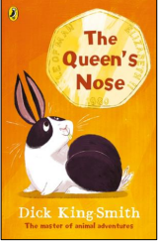  Classic short novel  Notable British author  Themes: magic, adventure and wishes  Entertaining, light humour, and a strong female protagonist who challenges stereotypes | Young, Gifted and Black  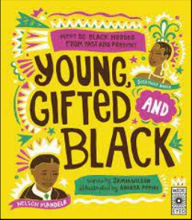  A beautifully illustrated anthology celebrating the achievements of black icons from history and the present day.  Themes: Hardship, challenges and prejudice, explores relevant social issues | 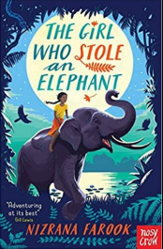  The Girl who Stole an Elephant  Female Sri Lankan protagonist and author  Thrilling adventure story set in Sri Lanka  Themes: social equality, justice, morality, friendship, political power and loyalty | 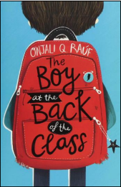  The Boy at the Back of the Class  Contemporary narrative telling the story of a Syrian refugee arriving in the UK.  Themes: kindness, friendship, bravery, sensitivity, community and relevant social issue.  Written by a female author specializing in interfaith projects | Varjak Paw  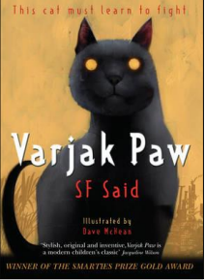  Contemporary narrative chapter book.  Full of suspense and mystery  The story of a cat who must learn the ways of his ancestors to survive  Themes: tenacity, bravery, self-belief, adventure, urban living | The Wind in the Willows  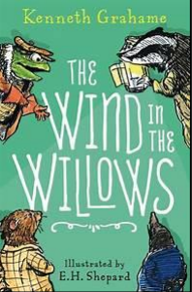  Heritage narrative text  Essential cultural reference  Full of rich, dense and challenging language to explore  A classic adventure story about friendship featuring anthropomorphism
Young, Gifted and Black  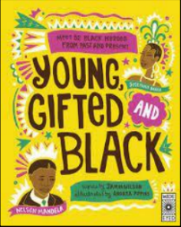  LINK: Black History Month  A beautifully illustrated anthology celebrating the achievements of black icons from history and the present day.  Themes: Hardship, challenges and prejudice, explores relevant social issues | The Girl who Stole an Elephant  Female Sri Lankan protagonist and author  Thrilling adventure story set in Sri Lanka  Themes: social equality, justice, morality, friendship, political power and loyalty | The Boy at the Back of the Class  Contemporary narrative telling the story of a Syrian refugee arriving in the UK.  Themes: kindness, friendship, bravery, sensitivity, community and relevant social issue.  Written by a female author specializing in interfaith projects | Varjak Paw  Contemporary narrative chapter book.  Full of suspense and mystery  The story of a cat who must learn the ways of his ancestors to survive  Themes: tenacity, bravery, self-belief, adventure, urban living | The Wind in the Willows  Heritage narrative text  Essential cultural reference  Full of rich, dense and challenging language to explore  A classic adventure story about friendship featuring anthropomorphism | The Raven  Edgar Allen Poe  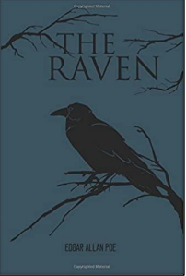  Heritage poem and seminal poet  Archaic and challenging  Language to explore implicit reference to mental health  A depth study of poetry and seminal poets

