Year 3 Literature Spine
Autumn 1 | Autumn 2 | Spring 1 | Spring 2 | Summer 1 | Summer 2
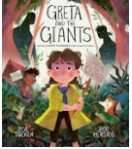  Greta and the Giant  Contemporary narrative picture book with additional non-narrative section  Themes:  Peaceful protest  Climate change  Children finding their voice | Leon and the Place Between  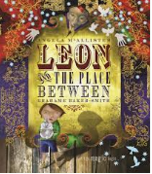  Contemporary narrative picture book  Contemporary narrative picture book  Themes:  Magic, adventure, friendship and the unknown | 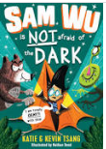  Sam Wu is Not Afraid of the Dark  Contemporary narrative chapter book  Part of a series  Humorous adventure story  Themes: conquering fear | Operation Gadgetman  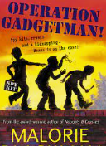  Contemporary narrative chapter book  Black female protagonist and author  Crime adventure story  Themes: gentle humour, friendship, family, tenacity, resilience | 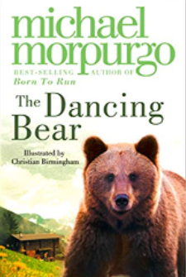  The Dancing Bear  Contemporary  narrative chapter book  Deeply moving story of a bear who is adopted by an orphan girl.  Rich language, with a sad ending  Themes: friendship, kindness, dilemmas, bravery, loneliness, animal cruelty and community | 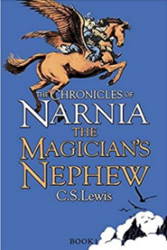  The Magician’s Nephew  Heritage narrative chapter book  The first book in the classic Narnia series  Essential cultural reference  Themes: adventure, friendship and bravery  Some religious references and representation of an ill parent  Opportunities to explore archaic language
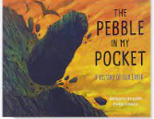  Pebble in my Pocket  Contemporary non-narrative picture book  Female historian author  Narrates the history of the Earth  High volume Tier 3 Science vocabulary | ‘Twas the Night Before Christmas  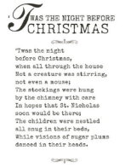  Seminal heritage poem  Essential cultural reference  Some archaic references  Themes: Christmas, traditions and modern representation of St Nicholas Entertaining and light | My Shadow  Robert Louis Stephenson  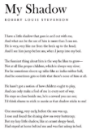  Told in first person  Some archaic references  Entertaining and Light

