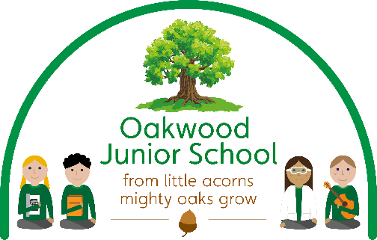

OAKWOOD JUNIOR SCHOOL
Holbrook Road, Alvaston, Derby DE24 0DD
Tel: 01332 571 231
e-mail: admin@oakwoodj.derby.sch.uk
www.oakwoodjuniorschool.co.uk

Headteacher: Mrs Atwal

[date]

11th December 2023

Dear Parents and carers
Relationship, Sex and Health Relationship –Year 5

In the summer term we decided not to use our RSE provision through SCARF to teach the children RSE as it was not appropriate for our children. We have decided to use Jigsaw as our RSE provider instead as this aligns more with the requirements for our children. In year 5 the children will therefore have two half terms of RSE, one directly after Christmas and one in the summer term. If you would like to discuss this part of the curriculum further I will be available from 2:45-3:30pm on Friday 15th December where you can have a look at the planning and resources in more detail.

At Oakwood Junior School we want all children to grow up healthy, happy, safe, and able to manage the challenges and opportunities of modern life. From September 2020, all primary age children are being taught Relationships and Health Education. These subjects are designed to equip your child with knowledge to make informed decisions about their wellbeing, health and relationships as well as preparing them for a successful adult life.

By the end of primary school, pupils will have been taught content on:

RELATIONSHIP EDUCATION | HEALTH EDUCATION
Families and people who care for me | Mental Wellbeing
Caring friendships | Internet safety and harms
Respectful relationships | Physical Health and fitness
Online relationships | Healthy Eating
Being safe | Facts and risks associated with drugs, alcohol and tobacco
 | Health and prevention
 | Basic first aid
 | Changing adolescent body
For further information please go to: https://assets.publishing.service.gov.uk/government/uploads/system/uploads/attachment_data/file/907638/RSE_primary_schools_guide_for_parents.pdf
At Oakwood Junior School we follow a PSHE and RSE programme in line with DfE guidance. Our PSHE and RSE curriculum is a progressive scheme of learning, building on prior knowledge. Learning from previous years is revisited and extended, adding new concepts, vocabulary, knowledge and skills, year on year as appropriate.

At part of the RSE and Health curriculum it is important that those at home are fully aware of the learning which will take place in school. We would therefore like to inform you that during the next half term the children in year 4 will start their RSE and Health topics: Changing me from Jigsaw. Please see below for further detail.

Changing Me
Main focus of lesson | Lesson Objective | Key Vocabulary
Unique Me | - I understand that some of my personal characteristics have come from my birth parents and that this happens because I am made from the joining of their egg and sperm  - I appreciate that I am a truly unique human being | - Personal  - Unique  - Characteristics  - Parents  - Gene
Having a Baby – alternative | - I understand what responsibilities there are in parenthood and the joy it can bring  - I can consider what has influenced my life and what might influence the lives of other people | - Feelings  - Responsibilities  - Carers  - Characteristics  - Language  - Mannerisms  - Influence
Girls and Puberty  (Includes a 1 minute animated diagram of the female reproductive system showing the menstrual cycle.) | I can describe how a girl’s body changes in order for her to be able to have babies when she is an adult, and that menstruation (having periods) is a natural part of this  - I have strategies to help me cope with the physical and emotional changes I will experience during puberty | - Puberty  - Menstruation  - Menstrual Cycle  - Periods  - Menstrual Pads  - Period Pants  - Tampons  - Vagina  - Vulva  - Ovaries  - Oestrogen  - Fallopian Tube  - Fertilised
Circles of Change | - I know how the circle of change works and can apply it to changes I want to make in my life  - I am confident enough to try to make changes when I think they will benefit me | - Circle  - Seasons  - Change  - Control
Accepting change | - I can identify changes that have been and may continue to be outside of my control that I learnt to accept  - I can express my fears and concerns about changes that are outside of my control and know how to manage these feelings positively | - Change  - Looking forward  - Excited  - Nervous  - Anxious  - Happy

If you have any questions or concerns regarding the RSE and Health curriculum please do not hesitate to get in touch with myself either by the Class Dojo or by email: nfray@oakwoodj.odysseyct.org.uk

Thank you for your time,

N Fray

Mrs N Fray – Deputy Head and RSE and Health Coordinator.

