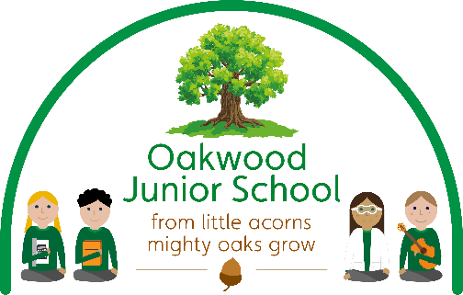

OAKWOOD JUNIOR SCHOOL
Holbrook Road, Alvaston, Derby DE24 0DD
Tel: 01332 571 231
e-mail: admin@oakwoodj.derby.sch.uk
www.oakwoodjuniorschool.co.uk

Headteacher: Mrs Atwal

[date]

11th December 2023

Dear Parents and carers
Relationship, Sex and Health Relationship –Year 4

In the summer term we decided not to use our RSE provision through SCARF to teach the children RSE as it was not appropriate for our children. We have decided to use Jigsaw as our RSE provider instead as this aligns more with the requirements for our children. In year 4 the children will therefore have two half terms of RSE, one directly after Christmas and one in the summer term. If you would like to discuss this part of the curriculum further I will be available from 2:45-3:30pm on Friday 15th December where you can have a look at the planning and resources in more detail.

At Oakwood Junior School we want all children to grow up healthy, happy, safe, and able to manage the challenges and opportunities of modern life. From September 2020, all primary age children are being taught Relationships and Health Education. These subjects are designed to equip your child with knowledge to make informed decisions about their wellbeing, health and relationships as well as preparing them for a successful adult life.

By the end of primary school, pupils will have been taught content on:

RELATIONSHIP EDUCATION | HEALTH EDUCATION
Families and people who care for me | Mental Wellbeing
Caring friendships | Internet safety and harms
Respectful relationships | Physical Health and fitness
Online relationships | Healthy Eating
Being safe | Facts and risks associated with drugs, alcohol and tobacco
 | Health and prevention
 | Basic first aid
 | Changing adolescent body
For further information please go to: https://assets.publishing.service.gov.uk/government/uploads/system/uploads/attachment_data/file/907638/RSE_primary_schools_guide_for_parents.pdf
At Oakwood Junior School we follow a PSHE and RSE programme in line with DfE guidance. Our PSHE and RSE curriculum is a progressive scheme of learning, building on prior knowledge. Learning from previous years is revisited and extended, adding new concepts, vocabulary, knowledge and skills, year on year as appropriate.

At part of the RSE and Health curriculum it is important that those at home are fully aware of the learning which will take place in school. We would therefore like to inform you that during the next half term the children in year 4 will start their RSE and Health topic: Changing Me from Jigsaw. Please see below for further detail.

Changing Me (year 3)
Main focus of lesson | Lesson Objective | Key Vocabulary
How Babies grow. | - Understand that in animals and humans lots of changes happen from birth to fully grown, and that usually it is the female who has the baby  - Can express how I feel when I see babies or baby animals | - Male  - Female  - Changes  - Birth  - Animals  - Babies  - Mother  - Growing up
Babies | - I understand how babies grow and develop in the mother’s uterus  - I understand what a baby needs to live and grow  - I can express how I might feel if I had a new baby in my family | - Baby  - Grow  - Uterus  - Womb  - Nutrients  - Survive  - Love  - Affection  - Care
Outside body changes | - I understand that boys’ and girls’ bodies need to change so that when they grow up their bodies can make babies  - I can identify how boys’ and girls’ bodies change on the outside during this growing up process  - I recognise how I feel about these changes happening to me and know how to cope with those feelings | - Change  - Puberty  - Control  - Breasts
Inside body changes | - I can identify how boys’ and girls’ bodies change on the inside during the growing up process and can tell you why these changes are necessary so that their bodies can make babies when they grow up  - I recognise how I feel about these changes happening to me and know how to cope with these feelings | - Puberty  - Male  - Female  - Testicles  - Sperm  - Penis  - Ovaries  - Egg  - Ovum/Ova  - Womb/Uterus  - Vagina  - Breasts
Family Stereotypes | - I can start to recognise stereotypical ideas I might have about parenting and family roles  - I can express how I feel when my ideas are challenged and might be willing to change my ideas sometimes | - Stereotypes  - Task  - Roles  - Challenge

If you have any questions or concerns regarding the RSE and Health curriculum please do not hesitate to get in touch with myself either by the Class Dojo or by email: n.fray@oakwoodj.odysseyct.org.uk

Thank you for your time,

N Fray

Mrs N Fray – Deputy Head and RSE and Health Coordinator.

