RSHE – Relationship, Sex and Health Education.
From September 2020 all children will be taught RSHE. This is to support all young people to be happy, healthy and safe – we want to equip them for adult life and to make a positive contribution to society.
What are the aims of RSHE?
There are four main aims for teaching RSHE
- To enable young people to understand and respect their bodies, and be able to cope with the changes puberty brings, without fear or confusion
- To help young people develop positive and healthy relationships appropriate to their age, development etc. (respect for self and others)
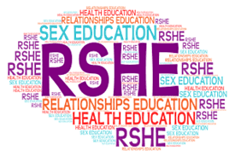
- To support young people to have positive self-esteem and body image, and to understand the influences and pressures around them
- To empower them to be safe and safeguarded
What will my child actually be taught in Sex Education?
The RSHE and PSHE ‘Changing Me’ unit is taught over a period of 6 weeks in the second half of the summer term. Each year group will be taught appropriate to their age and developmental stage. Please note: at no point will a child be taught something that is inappropriate; and if a question from a child arises and the teacher feels it would be inappropriate to answer, (for example, because of its mature or explicit nature), the child will be encouraged to ask his/her parents or carers at home, and the question will not be answered to the child or class if it is outside the remit of that year group’s programme. The areas covered are:
- Year 3 How babies grow and how boys’ and girls’ bodies change as they grow older
- Year 4 Internal and external reproductive body parts, body changes in girls and menstruation
- Year 5 Puberty for boys and girls, and conception
- Year 6 Puberty for boys and girls and understanding conception to birth of a baby
All lessons are taught using simple, child-friendly language and pictures, which help children understand changes more effectively.
Can I withdraw my child from RSHE teaching?
Parents/carers have the legal right to withdraw their children from the RSE included in the PSHE curriculum. But they are not permitted to withdraw their child from the Sex Education included in the National Science Curriculum. If you are considering taking your child out of RSHE lessons, please consider the following:
• All the other children in your child’s class will have been taught this information and may well talk to your child about it, perhaps in the playground… and potentially mislead them or confuse them as a result. It may prove far better to allow experienced and sensitive teaching staff to teach your child in a progressive, developmental way that is grounded in research.
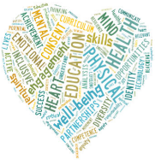
- They will be learning about reproduction in Science lessons. The RSHE in PSHE will echo this and will concentrate on teaching children how to enjoy healthy, appropriate relationships, improve self-esteem and self-confidence, and make healthy, informed choices. When viewed this way, it is hoped that RSHE won’t be seen as contentious or a cause for concern, but rather as helpful.
- Talk to your child’s teacher. Often, when parents and carers find out what is in the RSHE
curriculum, their fears are allayed as they can appreciate it is in the best interests of their child’s
life-long learning.
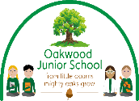
RSHE should be a partnership between the school and the parents/carers, working for every child’s safety and benefit.

